The University of Auckland
Department of Electrical and Computer Engineering

OASIS USER MANUAL
➲

OASIS USER MANUAL
Edition 1, December 2004

Eric Wong
Abbas Bigdeli

preface

OASIS (Online Assessment System with Integrated Study) is a web based assessment system developed by the Department of Electrical and Computer Engineering at The University of Auckland. It allows students to do practice questions and sit online tests for their courses. OASIS makes an excellent learning tool for students doing engineering and science courses because it provides questions for practice, and its instant marking capability also offers helpful feedback for the students to check their understanding and monitor their progress. OASIS also saves staff from marking assessments manually and therefore eliminates human error in the marking.

For questions to be available online, they must first be designed and then encoded in the specific format accepted by OASIS. As OASIS quickly gains popularity among courses, more and more people, mainly students, are employed for encoding the questions. It is the purpose of this manual to provide a complete guide to those who are new to designing and encoding questions and anyone who just wants to learn more about OASIS.

This manual begins with an introduction to what OASIS is, followed by a guide for navigating through different parts of the system. Five chapters are then devoted to all the aspects of designing, encoding and managing questions. An example question is encoded as we progress through the chapters to illustrate the concepts covered. The last chapter presents details in creating and administering a course assessment.

We would like to thank the Department of Electrical and Computer Engineering for its support for the project, Colin Coghill who designed and programmed OASIS, and the many other people who made OASIS and this manual possible.

Please note that OASIS is constantly under development and improvement. We will try our best to keep this manual as current and accurate as possible. If you have any questions regarding this manual, please contact us at oasis@ece.auckland.ac.nz. Lastly, we invite you to log on and experience OASIS at:

http://www.ece.auckland.ac.nz/oasis/

Eric Wong
Author

Abbas Bigdeli
Editor

December 2004

contents

CHAPTER 1. Introduction to OASIS 1
1.1 What is Oasis 1
1.2 Who can access OASIS and what they can do 1
1.3 Current and future development 2
1.4 Help and Support 2
CHAPTER 2. Navigating Through OASIS 3
2.1 Getting Your Account 3
2.2 Loggin in 3
2.3 Sitemap 4
2.4 Changing Your Password 5
CHAPTER 3. Attempting Questions 6
3.1 Practice Exercises 7
3.2 Sitting an Assessment 9
CHAPTER 4. User Administration 16
4.1 Access Rights 16
4.2 Adding and Removing User Access Rights 17
4.3 Changing User Password 19
4.4 Creating New User Account 19
CHAPTER 5. A Worked Example of Creating a Question 20
5.1 The Worked Example 20
5.2 Features 21
CHAPTER 6. Designing Questions 22
6.1 The Question Creation Process 22
6.2 How OASIS Generates A Question 23
6.3 How Oasis Marks A Question 24
6.4 Types of Questions 26
6.5 Using Images 27
6.6 Changing Text in a Question 29
6.7 Tolerance, Marks and Comments 30
6.8 Limitations 31
6.9 Guidelines for Designing Questions 32
6.10 Designing for the Example Question 32
CHAPTER 7. Creating Questions on OASIS 34
7.1 Creating a New Course on OASIS 34
7.2 Course Administration 35
7.3 Creating New Categories 36
7.4 Question Database 37
7.5 Creating New Questions 38
7.6 Positioning and Hiding Questions 39
7.7 Copying, Moving and Deleting Questions 40
CHAPTER 8. Entering and Editing Questions on OASIS 42
8.1 The Question Editor 42
8.2 HTML Template 43
8.3 Data File 50
8.4 Smart Marking 55
8.5 Putting Everything Together 59
8.6 Notes 60
CHAPTER 9. Administration of Course Assessments 61
9.1 Creating an Assessment 61
9.2 Modifying an Assessment 63
9.3 Retrieving Assessment Results 63
9.4 Deleting Assessments 65

CHAPTER 1. Introduction to OASIS

1.1 What is Oasis

In 1999, the then Head of the Electrical and Electronic Engineering Department, Professor John Boys, envisioned an online system that could help students to better understand the theory of electronic circuits by providing practice questions with instant marking. Clearly, such a system can also be used to provide online assessments which are capable of providing each student with a randomly generated variation of the questions from a large question database. Marking the assessments automatically, the system provides accuracy and consistency in marking, and saves staff time.

Colin Coghill took up the challenge and programmed a prototype for the system as his Master of Engineering project. The system was called OASIS (Online Assessment System with Integrated Study).

The prototype system, which was then written with PHP, was tested on a few courses for a couple of years, during which time Dr Abbas Bigdeli provided much useful feedback that guided the development of the system. In 2002, OASIS was completely rewritten by Colin using Python. The system quickly gained popularity. After continuous effort in bug fixes and adding new features, Version 3.5, October 2004 of OASIS was officially released in July 2004. Today, OASIS is used by more than 10 courses in the Department of Electrical and Computer Engineering and the Department of Physics, with some courses running over 100 questions. Many other courses both within and outside the departments have expressed interest in incorporating OASIS as a strategic teaching tool.

OASIS can be accessed at: http://www.ece.auckland.ac.nz/oasis/

1.2 Who can access OASIS and what they can do

Currently, anyone who has access to the university’s NetAccount service would already have access to OASIS. People who do not have access to NetAccount may also be given access to OASIS upon request (See Section 2.1 Getting Your Account).

Each course employing OASIS has an assigned user administrator, who has the authority to decide who may access the practice questions and assessments of the course and what they are allowed to do with them. The users for each course can be grouped into two classes – students and staff. Note that an OASIS user may have different access rights for different courses. For example, a user may have staff access for the ELECTENG101 course that he teaches, but only have student access to the PHYSICS710 course which he is taking as a student. The following outlines what each class of users can do under a particular course.

Student users may do practice questions as many times as they like, so long as the questions are available. They may also participate in the course assessments such as tests and assignments. Every time a student chooses a question, a variation of that question is randomly selected from a large question database. For example, the resistor values in a circuit are randomly picked from a large predefined set every time a question is loaded for a user. Upon submitting their answers for a question, OASIS immediately marks the answers, displays the correct answers and whether the user was correct for the answer they submitted for each sub-part of the question. The system will also display the score that the student received for that particular question.

At the top level of staff access is the user administrator. At the time a course is first associated with OASIS, a user must also register as the user administrator (See Section 2.1 Getting Your Account). The user administrator may assign any of the following rights (See Section 4.1 Access Rights) to the users under his/her course to:

- Add or delete a student user
- Access the question database, i.e. to add, modify, move, hide and delete questions
- Create, configure and delete online assessments
- View the statistics of the course assessments, both for the whole class or to search for a particular student user
- Modify the scores of the course assessments

Note that only the user administrator may change the access rights of any user (student or staff) in the course. A user granted any of the above access rights automatically becomes a staff user. Staff users have all the access rights of a student user.

1.3 Current and future development

OASIS is constantly under development in bug fixes and the enhancement of the system’s functionality, stability, reliability, efficiency, aesthetic and user-friendliness. For example, a long term goal is to separate the marking function of the system. That is, OASIS will generate the questions and collect the answers which will then be marked by an external marking application. This allows the possibility of developing more sophisticated marking schemes which will not be restricted by the architecture and processing capability of OASIS. There are also plans to integrate OASIS with CECIL, another online learning system used within the university.

1.4 Help and Support

The best effort will be made to keep this manual as current and accurate as possible. Any enquiry regarding OASIS not covered in this manual and any report of bugs can be directed to OASIS staff by email at oasis@ece.auckland.ac.nz.

CHAPTER 2. Navigating Through OASIS

2.1 Getting Your Account

Any person with access to the university NetAccount (aka NetLogin) service, i.e. people who have a NetID or UPI, would also be able to access OASIS.

If you do not have access to NetAccount, you may still apply for an OASIS account by sending an email to oasis@ece.auckland.ac.nz. Please include in the email your personal details, your preferred login name and why you would like access to OASIS. Upon successful application, an account will be created and an email containing your login name and password will be sent to you.

Alternatively, you may obtain access to OASIS by applying for a NetID from the university. After obtaining your NetID, you will automatically become a registered user of OASIS. Please note that this may take up to 24 hours. If you require urgent access, please email oasis@ece.auckland.ac.nz.

2.2 Loggin in

Log in at the OASIS homepage at http://www.ele.auckland.ac.nz/oasis. You may access OASIS within the university network or from home through the internet.

Enter your UPI (NetID) (e.g. jtho567) as the username and your student / staff ID number (e.g. 2345678) as the password, as shown below:

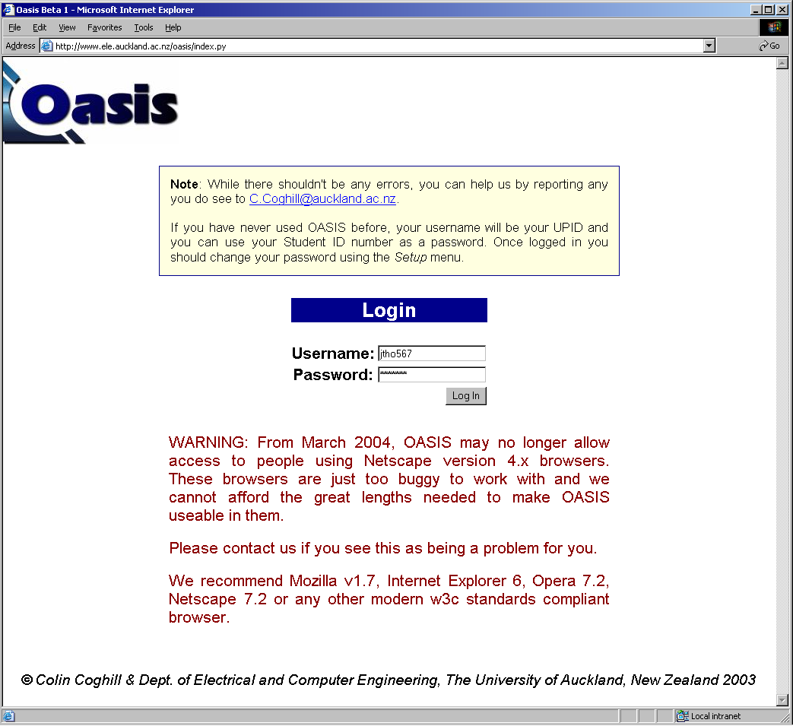

Figure 2.2.1 Logging into OASIS
Contact your course coordinator or oasis@ece.auckland.ac.nz if you have problem logging in.

2.3 Sitemap

Upon successful log in, you will be directed to the OASIS home page, shown below in Figure 2.3.1. Note that a navigation menu is available at the top right of the page, providing quick and easy access to the main sections of OASIS.

Quick navigation menu

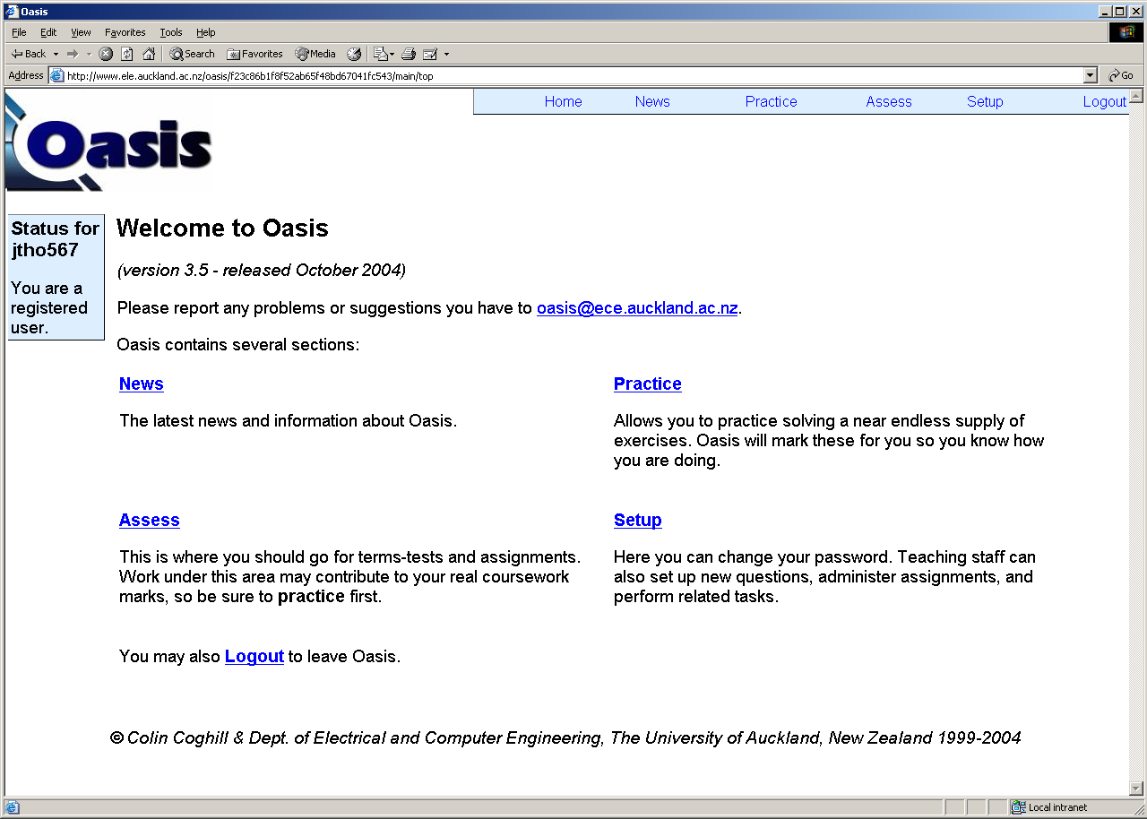

Figure 2.3.1 The OASIS home page

OASIS is divided into three main sections – practice, assess and setup. The following sitemap shows the functions of various parts of OASIS.

Change Password
User Administration
Course Administration
Setup
Assess
Practice
Home
Log in: http://www.ele.auckland.ac.nz/oasis/ (Username: UPI, Password: ID)
This is where students go for practice questions.
Pick a course to view a list of available topics and questions.
This is where students go for their term-tests and assignments.
Change your password here.
User administrators may add or edit user accounts and assign access rights to users in their courses.
Staff may enter/edit questions, view class/student statistics for practices/assessments, and view/alter marks for their courses.
News
You can find the latest news and information such as development progress about OASIS here.

Figure 2.3.2 Sitemap of OASIS

2.4 Changing Your Password

You should change your password at your first login. To change your password, go to Change Password under Setup. You may choose any alphanumerical password between 1 to 28 characters.

CHAPTER 3. Attempting Questions

Below is a sample of the questions you might see in a practice exercise or assessment:
Course
Topic / Category

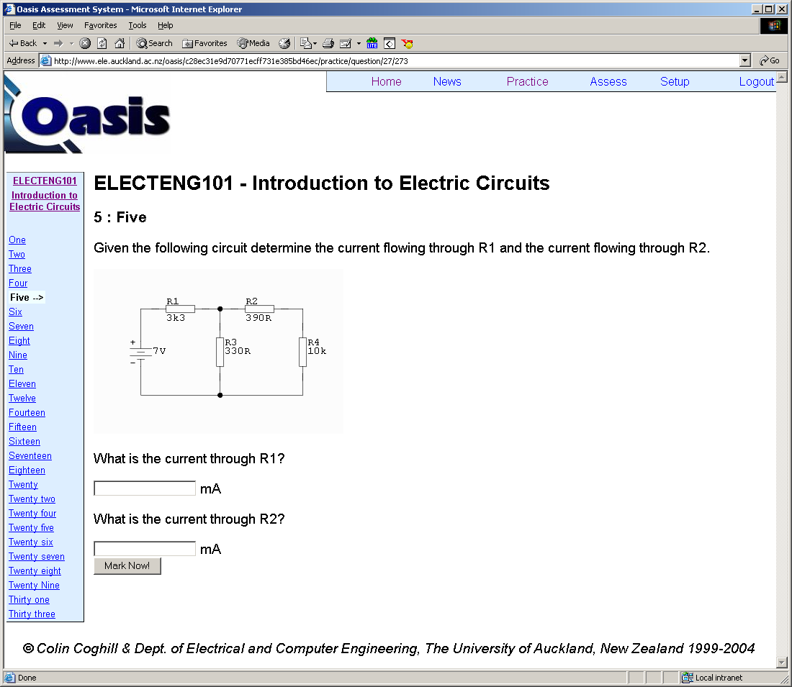
Question number
Question Title

Figure 3.0.1 A sample question

The parameters of a question may vary between a set of pre-designed values. In the above question, a new set of resistor values is selected from the question database every time the question is loaded. The following figure shows two variations of the above circuit.

In fact, virtually all aspects of a question may be designed to change every time it is loaded. For example, in the above question, instead of asking the current through resistors R1 and R2, the question could ask the current through resistors R3 and R4 next time it is loaded, or the question could even contain a new part.
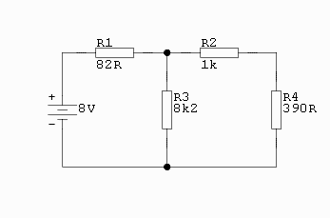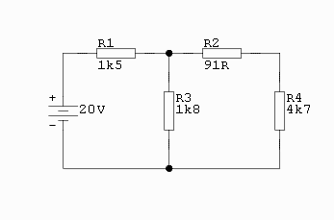
Figure 3.0.2 Illustration of the change of parameters each time the question is loaded

Guidelines for anyone attempting a question:
- After completing the answers, click the button to mark your answers.

- Each part of a question accepts answers within a preset tolerance of the correct answer. Most questions simply use the OASIS default tolerance of 1%. For example, if the tolerance for an answer is set to be 1.5% and the correct answer is 100, then any answer between 98.5 and 101.5 will be marked correct.

- To ensure that your answer is within the preset tolerance, do not round any values in your working. Round your final answer to 4 significant figures.

- A question may be designed to allow for consistent errors between different parts of a question, i.e. to credit an answer that is incorrect, but consistent with a previous wrong answer. However, most of the questions do not support this feature. Refer to Section 6.3 How OASIS Marks a Question and Section 8.4 Smart Marking to learn how to write a question that supports consistent errors.

3.1 Practice Exercises

Practice exercises are provided in the Practice section, which students may attempt as many times as they wish in their own time to supplement their study.

On the first page of the practice section is a list of all the available courses providing practice problems, as shown in Figure 3.1.1 below. Upon selecting a course, a list of categories or topics is presented along with the number of practice exercises available in each category. Figure 3.1.2 shows the available categories under ELECTENG101. A menu is available on the left hand side of the page providing quick links to practice exercises for other courses.

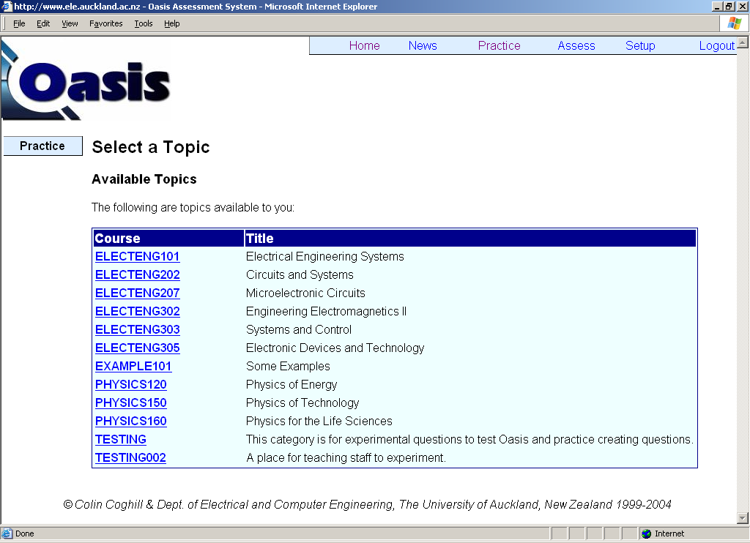

Figure 3.1.1 List of available courses in the practice section

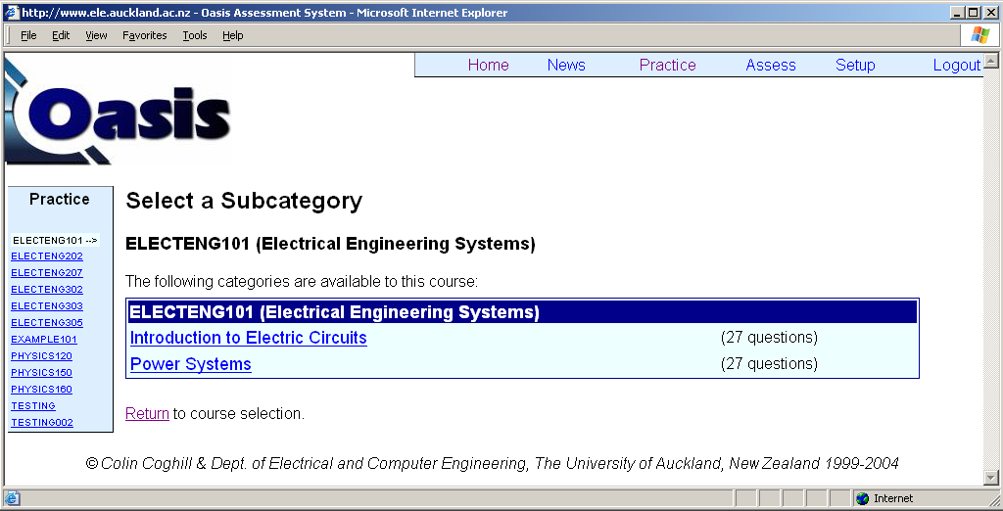

Figure 3.1.2 Topics under ELECTENG101
3.2 Sitting an Assessment

Students can find their online assignments and exams in the Assessment section. Assessments are grouped into three categories in the Assessment section – Available Assessments, Upcoming Assessments and Past Assessments. Each assessment has a start date and time when they become available; an end date and time when they become expired; and a duration time within which the students must complete their assessment.

Assessments which are created but not due to become available are listed under Upcoming Assessments. When the start time of an assessment is reached, it is moved into the list of Available Assessments (you may need to reload your page to see this). Students can then sit their assessment by choosing from the listed courses and assessment titles. An assessment expires at its specified end time where it is moved to the list of Past Assessments and no more new attempts are allowed.

Figure 3.2.1 shows the three lists of assessments. Notice the upcoming Sample Assessment for the course EXAMPLE101. We will be using it to discuss the various aspects of sitting an assessment.

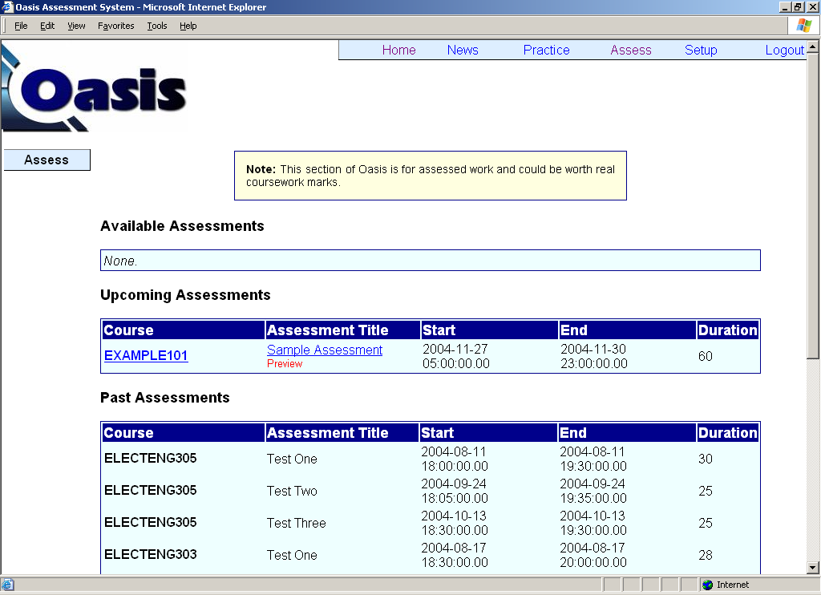

Figure 3.2.1 List of all assessments

At its specified start time, the EXAMPLE101 Sample Assessment moves to the list of Available Assessments.

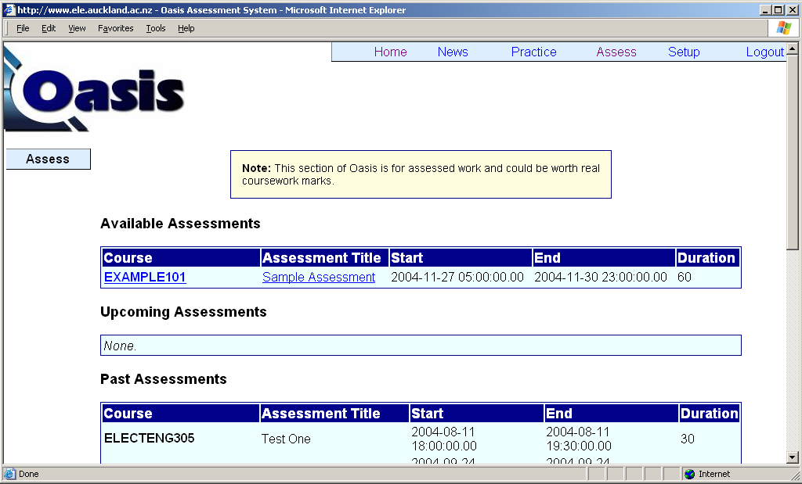

Figure 3.2.2 EXAMPLE101 Sample Assessment becomes available to students

After selecting our Sample Assessment, we see an instruction page:

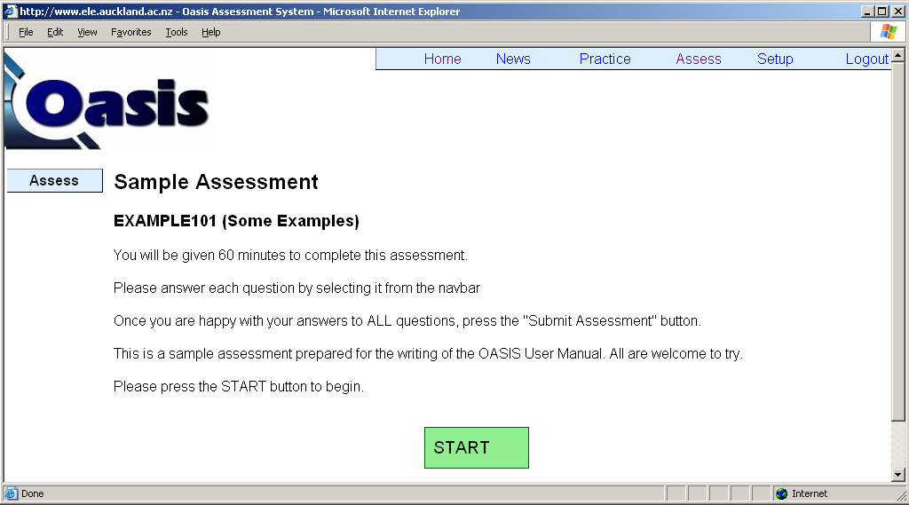
Instructions specific to this assessment

Figure 3.2.3 Instruction page of EXAMPLE101 Sample Assessment
Anyone who can access OASIS may attempt any available assessments, even if they are not enrolled in the respective courses. After clicking on the START button, the assessment is started and the first question is presented, as shown in Figure 3.2.4. Links to other questions in the assessment are provided on each question page.

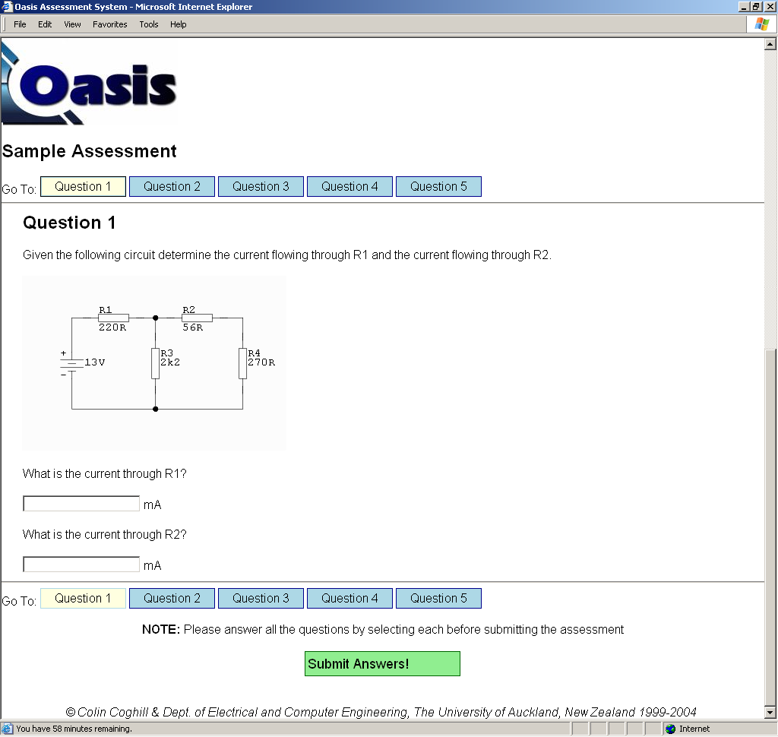

Figure 3.2.4 First question of EXAMPLE101 Sample Assessment

Students may choose to do the questions in any order. After completing the answers for a question, the answers are saved when the student attempts another question by clicking on its respective button. When the student has completed all the questions, they should click on the Submit Answers! button to submit their final answers for marking. The students may change their answers as many times as they want, before they click on the Submit Answers! button and within the time limit of the assessment. Unlike practice exercises, the version of a question does not change as a student navigates across the different question pages.

After saving the answers for a question (by clicking on the link to another question), the student can re-visit that question by clicking on that question, and the answers saved previously are automatically retrieved and loaded into answer fields.

Because answers are saved when moving to another question, it is extremely important that students do not use the browser’s BACK button to navigate to a previous question before saving the answers of the current question. For example, a student may have completed question 1 of the assessment. After filling in their answers for question 2, they may want to re-visit question 1. The proper way of doing this is to click on the button that says Question 1, which automatically saves the answers entered for question 2. If the student instead returns to question 1 using the BACK button of the browser, it results in the answers for question 2 unsaved and lost. If during an assessment, any student realises that this unfortunate incident has happened to them, they should try to redo the question within the remaining time. Students who only realise after the assessment that they had lost their answers through the use of the browser’s BACK button should report to their course coordinator, who may choose to allow them a second chance to attempt that question within a defined time limit.

Notice on Figure 3.2.4 that the remaining time for the student to complete their assessment is shown on the status bar on the bottom left corner. This time is updated continuously so students can easily keep track of the time they have left. Figure 3.2.5 shows that students receive a reminder when they have only 3 minutes left to complete their assessment. They are reminded again with 1 minute left, as shown in Figure 3.2.6. From this point, student have 1 minute to save and submit their answers. At the finish time of the assessment, students are reminded to submit their answers (Figure 3.2.7). Any un-saved answers will be lost.

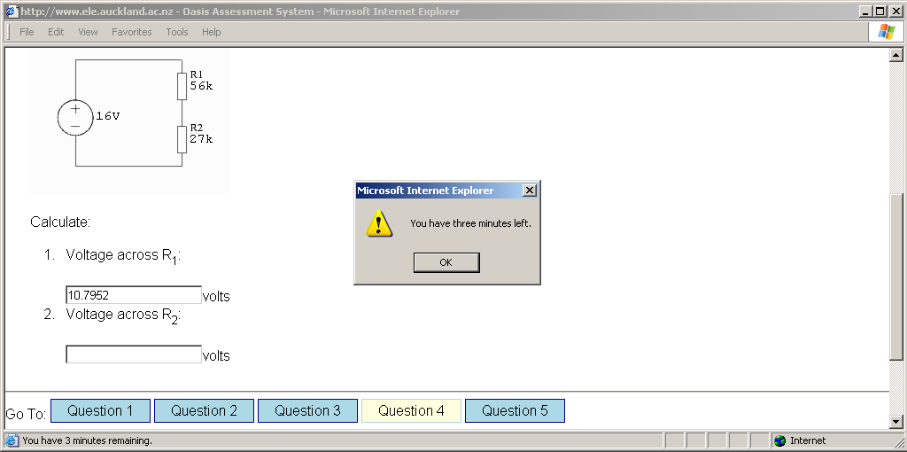

Figure 3.2.5 System reminder with 3 minutes remaining

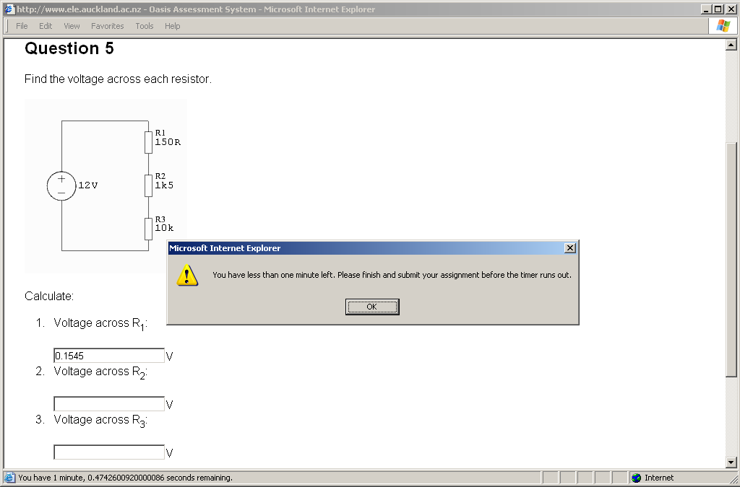

Figure 3.2.6 System reminder with 1 minute remaining

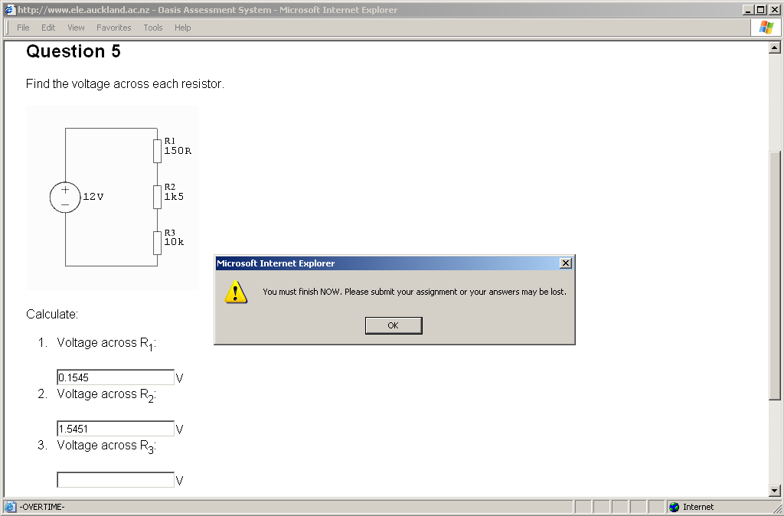

Figure 3.2.7 Time is up. Students must submit their answers.
After submission, the answers are marked and the results returned to the students immediately. Figure 3.2.8 shows the results we obtained in our attempt at the ELECTENG101 Sample Assessment.

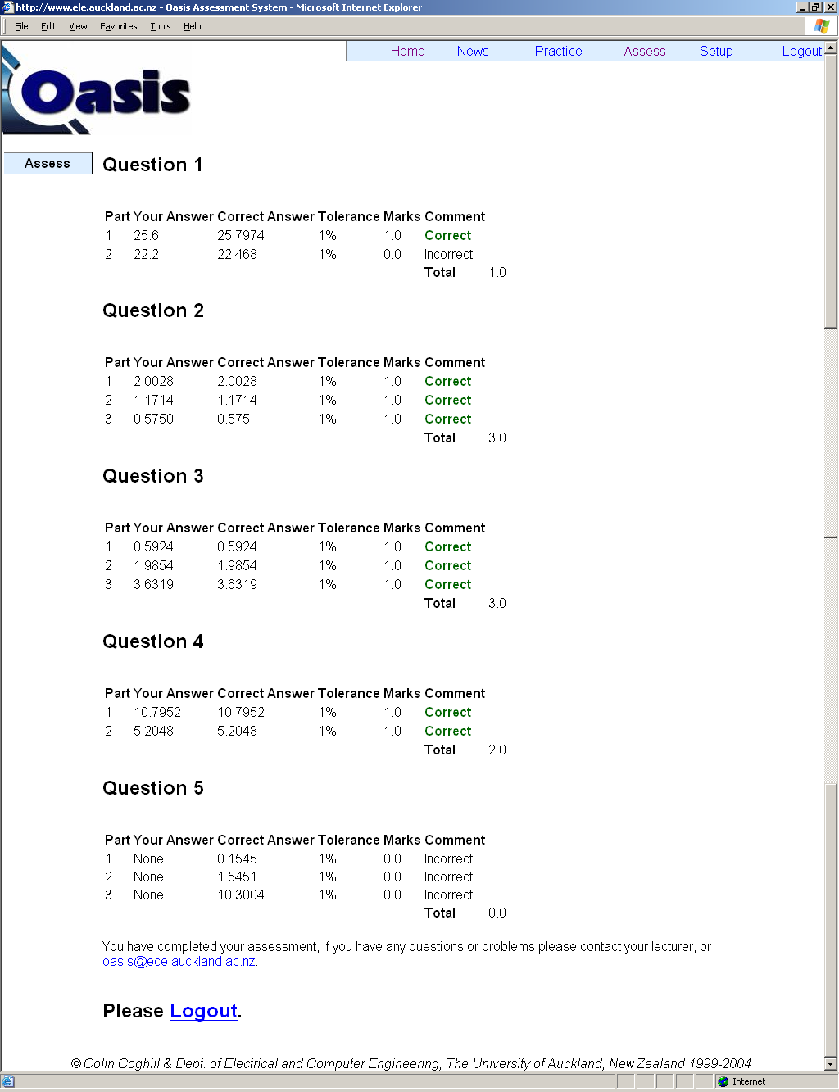

Figure 3.2.8 Results Page
Notice from our results:

- Our answer to Question 1, Part 1 is not exactly the same as the model answer. However, since our answer is within the default tolerance of 1% of the model answer, we were marked correct.

- Our answer to Question 1, Part 2 is fairly close to the model answer. However, since our answer differs from the model answer by more than the default tolerance of 1%, our answer was marked incorrect.

- We did not save our answers for Question 5 by the time the assessment time ran out and we were forced to submit our answers. Therefore, even though we did fill in the answers to two parts of Question 5, as shown in Figure 3.2.7, they were not submitted for marking.

Each student may only attempt an assessment once. Students attempting the assessment again will receive a notice of “Assessment Already Submitted” as shown in Figure 3.2.9. Students will not be able to submit their assessment again.

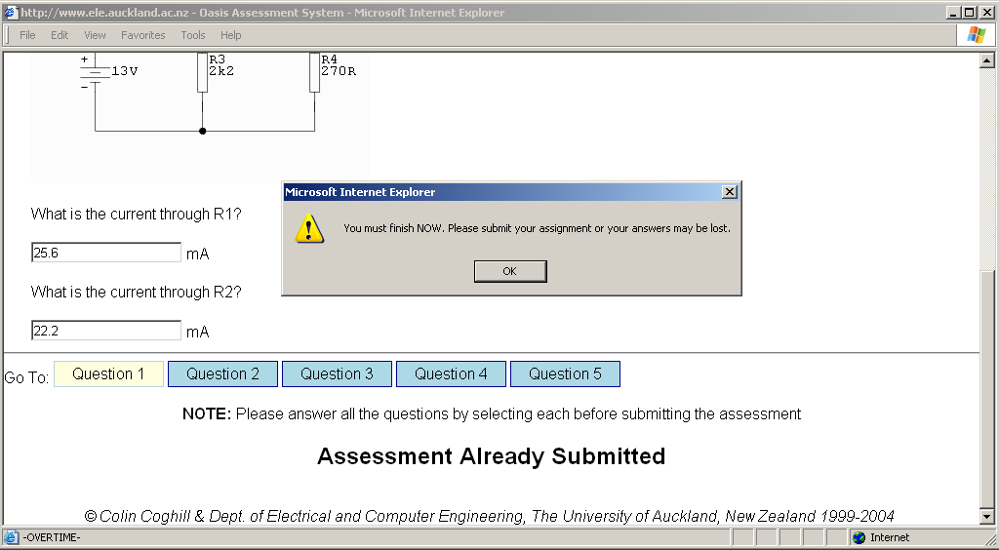

Figure 3.2.9 Students may attempt an assessment only once

If any student experiences a PC crash or any unfortunate incident that resulted in the closing of their browser application during an assessment, they can simply log into OASIS and start their assessment again. Their saved answers and remaining time from the previous session will be automatically loaded into the new session, so students can continue on their assessment from where they left off.

CHAPTER 4. User Administration

4.1 Access Rights

OASIS users can be grouped into two classes – students and staff. All user accounts are created as student accounts, which only allow their users to attempt practice exercises and to sit online assessments (for any course). Staff users have special access rights which allow them access to course administration functions, such as creating new practice questions, publishing an assessment, and viewing and altering assessment results.

Staff access rights are exclusive to a course and therefore a user may hold different access rights for different courses. This improves security of the content of the courses. For example, a staff may only be granted access to view and alter marks for the courses he/she teaches, but not for other courses. A lecturer may therefore have staff access for the ELECTENG101 course that he teaches, but only have student access to the PHYSICS710 course which he is taking as a student.

Each course employing OASIS has an assigned user administrator, who is usually the course coordinator. The user administrator has the authority to assign or remove access rights to other users for his/her course (and not any other course). Therefore if you require any special access, for example, to enter questions for a course, you need to contact the respective course coordinator.

Table 4.1.1 describes the access rights that may be granted by the user administrator to any user:

Access Rights | Privileges
User Administrator | Assign any access rights to any user for the course he or she administers.
Question Editor | Enter new practice questions and modify existing questions.
Alter Marks | View and alter assessment marks.
View Marks | View but not alter assessment marks.
Preview Questions | View questions that are not activated for student participation.
Preview Assessments | View assessments that are not due for student participation.
Create Assessments | Create new assessments.

Table 4.1.1 Description of access rights

Here is a suggestion of how the access rights should be assigned - the user administrator could grant all the above access rights to other teaching staff of the course, but may choose to limit the right to modify the assessment scores (Alter Marks) to himself/herself. Any student employed for encoding questions should only be given the rights to access the question database (Question Editor and Preview Questions).

4.2 Adding and Removing User Access Rights

User Administrators may add or remove user access rights at the User Administration page under the Setup section. All users other than user administrators are restricted from accessing the page, as shown in Figure 4.2.1.

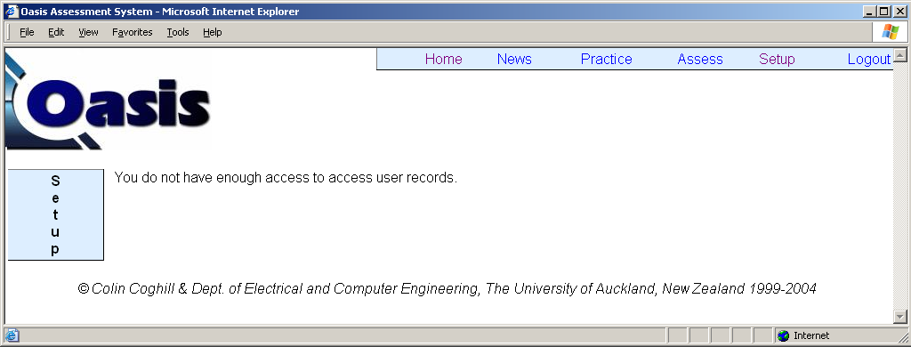

Figure 4.2.1 Only user administrators are allowed to access the user administration page

User administrators are first asked to search for the user whose access rights are to be modified, as shown in Figure 4.2.2. You may search for the user’s surname, first name, university ID, or user name, but not a combination of these. In this example, we are trying to modify the access rights of the user John Thompson. Since we know his ID number is 1234567, we use this for our search instead of using his first name or last name which would otherwise return a long list of users.

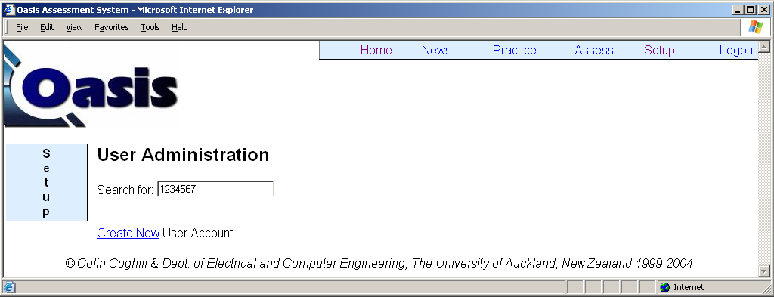

Figure 4.2.2 Search for user to modify his or her access rights

The search results are returned and shown in Figure 4.2.3. Interestingly, we have two users with the same ID number. The other user, tess, is a miscellaneous user created on the system for administrative and testing purpose. We select John Thompson by clicking on his user name jtho567.
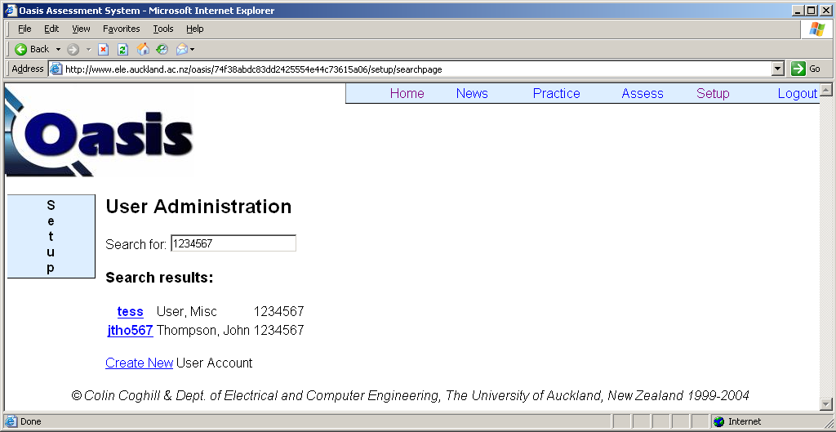

Figure 4.2.3 Results for searching users

We currently have user administrator access to course EXAMPLE101, therefore we are able to assign access rights for this course (and not other courses), as shown in Figure 4.2.4. Since we are employing John Thompson as a question encoder, we are assigning access rights of Question Editor and Preview Questions to him.

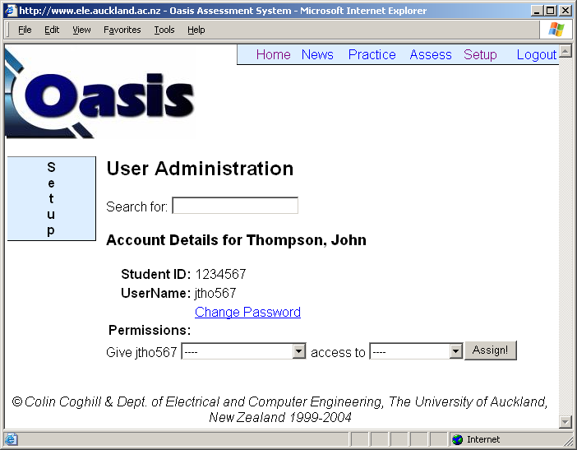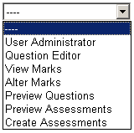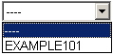

Figure 4.2.4 Assigning user access rights

Figure 4.2.5 shows the assigned rights which can be removed by clicking on the remove buttons.

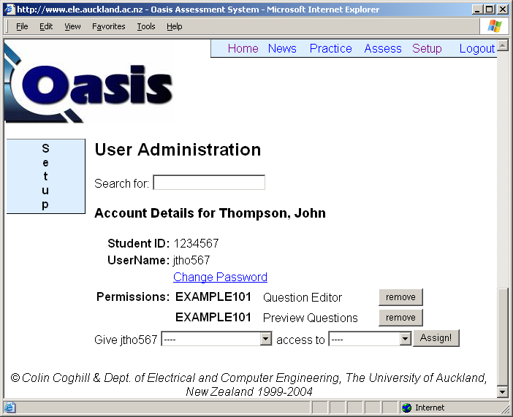

Figure 4.2.5 Updated user access rights

4.3 Changing User Password

If the user administrator wishes to change the password of any user, he or she can do so by following the Change Password link after searching for the specific user. The user administrator is not required to know the current password of the user.

4.4 Creating New User Account

As shown in Figure 4.2.2, a user administrator may also create a new user in the User Administration page by following the Create New User Account link. Details required for the new user are: Username, First Name, Surname, Student ID and Password.

CHAPTER 5. A Worked Example of Creating a Question

An example question will be created as we progress through the next three chapters in order to illustrate all the concepts covered in creating a question on OASIS, from designing to encoding to uploading.

5.1 The Worked Example

We would like to create a question with the following attributes:

- It will be used in the course EXAMPLE101
- It will be under topic Chapter 1
- It will be the first question in the topic
- The title of the question will be A Really Easy Question

This is how our final question will look:

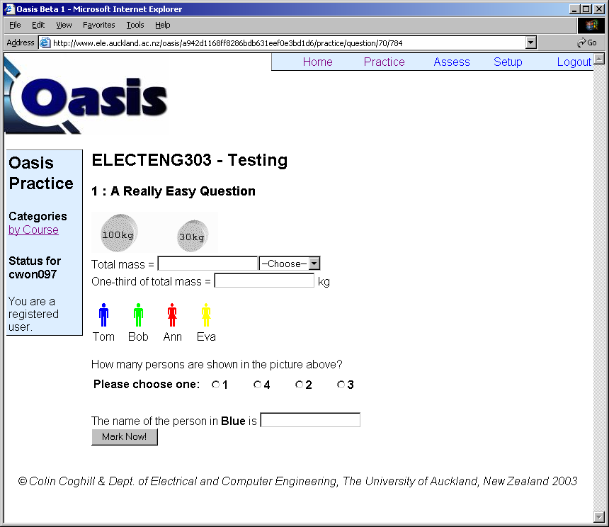

Figure 5.1.1 Screenshot of our example question
5.2 Features

The following figure presents an example problem that will be used to illustrate the features available.
The mass displayed on the objects changes every time.
Feature: Text on images (Sec. 8.2.2 and Sec. 8.3.1)

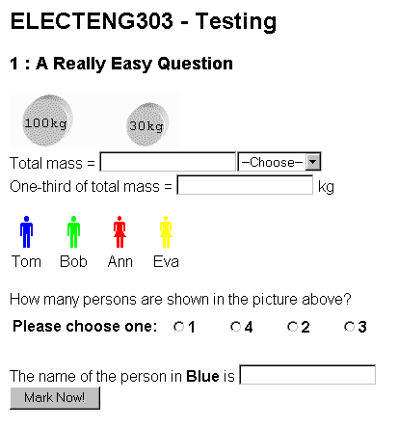

2 marks for the correct answer. Features: Numerical answer (Sec. 8.2.4), Setting mark (Sec. 8.3)

Choose units: kg, g, N. (1 mark)
Feature: Drop-down list (Sec. 8.2.4)

2 marks for the right answer, or an answer consistent with Part 1.
Feature: Consistent errors (Sec. 8.4)

Changing available choices.
Feature: Multi-choice (Sec. 8.2.4)

Requires a non-numerical answer. (1 mark)
Feature: One-word answer (Sec. 8.2.4)

Different pictures may be displayed.
Feature: Changing picture (Sec. 8.2.3)
May ask for a different colour.
Feature: Changing variable (Sec. 8.2.5)

Figure 5.2.1 Features illustrated by an example problem

CHAPTER 6. Designing Questions

This section discuses what you need to know for designing an OASIS question, the first step in the question creation process.

6.1 The Question Creation Process

The process of creating a question on OASIS is summarised in the following flowchart:

Question encoder encodes/edits question
Teaching staff verifies the question encoded
Satisfied

Activation of question for practice/assessment
Instructor designs question on paper
Yes
No

Figure 6.1.1 Flowchart of the question creation process

The creation of a new question on OASIS starts with a member of teaching staff designing a question on paper. The design of the question is then passed on to a question encoder, usually a student employed for this purpose, who then encodes the design into a format that OASIS accepts. The question encoder will then notify the designer once the question is encoded and uploaded onto OASIS. It is necessary for the question designer, or another member of teaching staff, to verify that the question has been encoded to the desired standard; and, by solving the question several times, verify that the answers stored on OASIS are accurate.

All questions should initially be created for staff access only. It is the responsibility of the lecturer/instructor to proof the questions and collaborate with the question encoder to ensure the standard and accuracy of the questions before they become available for students. Once a question is verified to be free of errors, it can be activated for student access (see Section 8.1 The Question Editor).

6.2 How OASIS Generates A Question

Question encoders clearly need to have a good knowledge of how to encode a question into a format that OASIS accepts. However, it is also crucial that any member of the teaching staff planning to write a question acquire a general understanding of what makes up a question in OASIS and what happens when a student attempts a question. Occasionally staff design questions that are very helpful to students’ study, but are simply beyond the capabilities of OASIS. Therefore it is important for teaching staff to keep in mind the functions and limitations of OASIS during the design of a question.

The following diagram summarises what happens in the creation of a question and what happens when a student attempts the question:

Question encoder encodes a question…
Student attempts the question…
<HTML>
................
................
................
</HTML>

Question written in HTML as a webpage

answers, parameters
answers, parameters
................
................
................
answers, parameters

Question written on paper

All the designed sets of question parameters and their corresponding answers are stored in rows in a text file



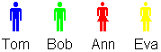

Images and other attachments used in the question

Figure 6.2.1 The three main components of a question
As shown in the diagram, the question encoder converts a question written on paper into the three main components that make up a question on OASIS. Following is a brief description of these three components, which are discussed in detail in Chapter 8, Entering Questions on OASIS.

- HTML template – Questions are written in HTML as webpages.

- Data file – The question encoder generates all the parameter sets that can appear in a question, together with the corresponding answers and stores these in a text file. Each line of the text file contains a set of parameters and their matching answers. When a question is loaded, a line is randomly picked from the text file and the parameters defined by this line will be displayed in the question. A data file typically contains between 200 to 500 lines (possible variations of the question).

- Attachments – These are the images used in the question.

6.3 How Oasis Marks A Question

A common misunderstanding of the mechanism behind generating and marking questions in OASIS is that question parameters are generated randomly when a question is attempted, and OASIS calculates the answers according to a set of predefined expressions. THIS IS INCORRECT! As discussed above, the data file contains the answers corresponding to each set of question parameters. This means that you must design all the parameter sets that can appear in your question and store them in the data file. For each set of parameters that you have, you must also calculate the matching answers and store their values (instead of the expressions for getting these values), also in the data file.

As shown in Figure 6.2.1, to generate a question, OASIS simply puts together the information you provide (HTML template, data file, attachments). The same happens in marking a question. OASIS can only mark a question with the answers you have provided in the data file. There are two types of marking system in OASIS – standard marking and smart marking – depending on how you want to use the predefined answers.

6.3.1 Standard Marking

Standard marking provides a simple form of marking where OASIS automatically compares the student answers with the correct answers stored in the data file. 1 mark is awarded for each correct answer (within the preset tolerance) and 0 for each incorrect answer. Since OASIS performs the marking automatically, all you need is the correct answers defined in the data file. There is no extra work required from the question designer or question encoder. However, the capability of this simple form of marking is limited; for example, consistent errors are not considered – the system simply compares an answer with the correct answer with no regard to its relationship with answers for the rest of the question. Figure 6.3.1 shows an example illustrating this shortcoming of standard marking.
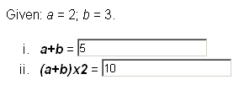
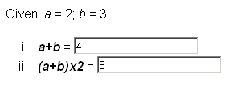
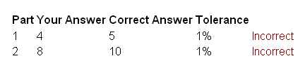
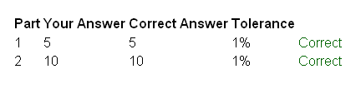

Figure 6.3.1 Standard marking does not support marking of consistent errors.

6.3.2 Smart Marking

Smart marking allows you to perform any mathematical and logical operation on the student answers and the correct answers. This allows your question to credit consistent errors. You might also want to use the smart marking feature when there is more than one correct answer for a question, for example, “blue”, “Blue” and “BLUE” may all be considered correct answers for a question. Where the data file can only provide one correct answer, you can define the other possible answers by using smart marking. Figure 6.3.2 shows the above question with smart marking supporting the marking of consistent errors.

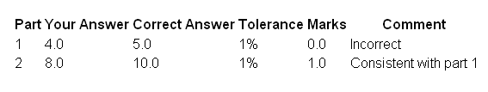

Figure 6.3.2 Marking of consistent errors supported in smart marking.

This section was only intended to show you that smart marking features are available. When you design a question, you do not need to specify whether you want standard or smart marking. Simply describe how the answers are to be marked; for example, if consistent error marking is required for a specific part of the question. The question encoder will meet the requirement using the appropriate type of marking during the encoding process.

It is important that you know what features OASIS does and does not support before you design a question. The next few sections introduce the features that you can incorporate into your question.

6.4 Types of Questions

Your question may contain one or more parts. Our example question has 5 parts to it:

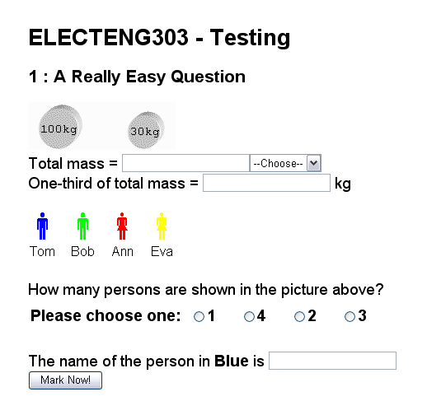
1
2
3
4
5

Figure 6.4.1 Five parts of the example question

OASIS requires each part to ask for an answer in one of four input formats:

Numerical: Accepts a numerical answer which will be marked to your designed tolerance. If you do not specify the desired tolerance in your question design, the default tolerance of 1% will be used. Parts 1 and 3 of the example question require a numerical answer.

Text: Accepts a string of characters. Any alphanumerical characters can be used. Answer is case sensitive and may contain white spaces. Part 5 of the example question accepts a text input.

Dropdown list: You can define a list of answers in a dropdown box. Students may select only one answer. You can have different choices and even a different number of choices in each row of the data file. For example, a dropdown list may provide the choices “Big / Medium / Small” in one version of a question, while the choices “Huge / Tiny” are provided in another version of the same question. The choices in a list are displayed in random order. For example, while a dropdown list may contain choices in the order of “Big / Medium / Small”, it may read “Medium / Small / Big” another time the same variation of the question is loaded. Part 2 of the example question uses a dropdown list.

Multi-choice: This works in the same way as a dropdown list, except that the students now answer by selecting the radio button associated with their choice. Again, you can have different choices and/or a different number of choices for different versions of the question. The choices are displayed in random order. Part 4 of the example question is a multi-choice question.

6.5 Using Images

You may include images in your question. There are two types of images – dynamic images and static images.

6.5.1 Dynamic images

It is possible to add text onto an image when your question is loaded. The text to be added comes from the data file (see Section 8.2.2 Default Image) and can therefore vary for different versions of your question. For example, this is extremely useful when you have an electronic circuit in your question and you want the circuit parameters (e.g. resistor values) to change every time a student attempts the question. This is illustrated in Figure 6.5.1. Your question may contain only one image that requires text to be added onto it when the question is loaded. This image is the dynamic image.

You can have any image for the dynamic image and any text to display on it. Black and white images are displayed exactly the same as the original image, but greyscale and colour images may be displayed with a reduced quality. Therefore it is recommended that you avoid using these images for your dynamic image if the quality of the image is crucial for the question. Animation in the form of GIF (Graphic Interchange Format) is also supported, but only the first frame of the animation will contain the added text. Due to the limited practicality of this, animation is generally not recommended for your dynamic image. Lastly, you are not required to have a dynamic image and, if you have one, it is not necessary to add text to it.

R1
43V
135R
101R
4R
70R
R1
Parameters + Answers set 1

Parameters + Answers set 325

Parameters + Answers set 400
Original image
Data file
Image displayed in question
When another student attempts the question…
R1
20V
100R
150R
10R
40R
R1
Parameters + Answers set 1

Parameters + Answers set 153

Parameters + Answers set 400
Original image
Data file
Image displayed in question
When a student attempts the question…
Original image does not contain the resistor values
Different sets of resistor values are recorded in the data file along with other parameters and the corresponding answers.

When the question is loaded, a record is randomly selected.
The selected set of resistor values is displayed on top of the original image.

Figure 6.5.1 Adding text to dynamic images

Our example question also uses a dynamic image. The original image and two examples of the image displayed in the question are shown below. Notice the added text and the reduced quality of the displayed images.

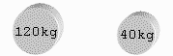
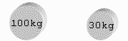
Original image
Final displayed image
Example 1
Final displayed image
Example 2

Figure 6.5.2 Dynamic image in the example question

6.5.2 Static Images

Static images are those images that do not require text to be dynamically added onto them when a question is loaded. You can have virtually any images including animations as static images in your question. Unlike dynamic images, you can have as many static images (or none) in your question as you want. In addition, you can prepare different versions of an image and have them come up randomly. For example, there is one static image in our example question and Figure 6.5.3 shows different versions of the image which may appear when students attempt the question.

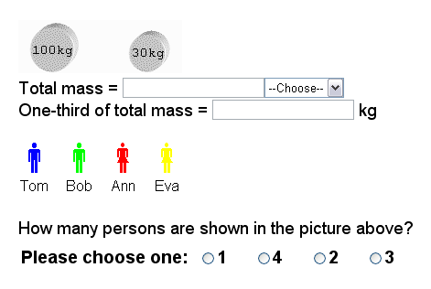

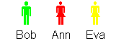
?

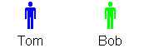

6.5.3 Static image in the example question

6.6 Changing Text in a Question

We have introduced two ways that you can have different versions of a question:

- Displaying different text on your dynamic image.
- Displaying different images for your static images.

You can also change the text in your question. This allows you to:

- Have a slight variation of one or more parts of your question.

Example 1:
“What is the current flowing through R1?”
“What is the current flowing through R2?”
“What is the current flowing through R3?”

Example 2:
“Which one of the three cars is the fastest?”
“Which one of the three cars is the slowest?”

- Have a totally different version of one or more parts of your question.

Example 1:
“What is the current flowing through R1?”
“What is the voltage at point A?”
“What is the equivalent resistance of the circuit?”

Example 2:
“Which one of the three cars is the fastest?”
“Who is driving the blue car?”
“In what direction is John driving?”

- Change one or more parts of your question so that they match the change in your static images.

From our example question:

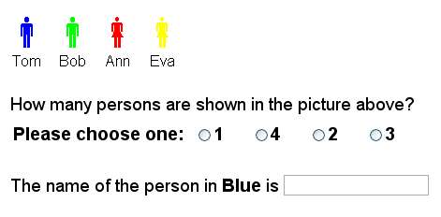
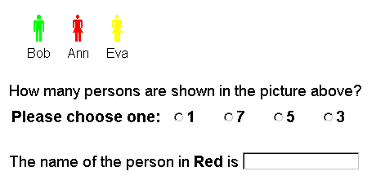

Figure 6.6.1 Changing the text of a question to match the change in a static image.

Note that the type of answers (numerical, text, multi-choice, dropdown list) for each part of the question must remain the same; only the text in a question may change.

6.7 Tolerance, Marks and Comments

For each part of your question, there are three attributes that you can define for marking the answer: tolerance, marks and comments.

Tolerance. As discussed in Chapter 3, each answer is marked to a tolerance value that you define. Tolerance is defined in terms of percentage difference from the correct answer. For example, if the correct answer is 200 and you would like to allow a tolerance of 1.5%, then any answers between 197 and 203 will be marked correct. If you do not define the tolerance value, OASIS will mark the answer to a default tolerance of 1%.

Marks. You can define how many marks you want to give for a correct answer. You can also define a different mark for answers that are partly correct, or answers that are consistent with a previous mistake. OASIS awards 1 mark for a correct answer and 0 mark for an incorrect answer by default if you do not define the marks.

Comments. OASIS provides comments on the student answers. You can define any comment you like depending on the student answers. Common comments include “Correct”, “Incorrect”, “Consistent with Part 3”, “Correct Unit” and “Wrong sign”. Figures 6.3.1 and 6.3.2 show three different comments provided for the question. OASIS returns “Correct” for a correct answer and “Incorrect” for an incorrect answer by default.

6.8 Limitations

From the above introduction to the mechanism of OASIS and the features supported by the system, we can observe a few limitations on the system’s capabilities that we must keep in mind when designing questions.

First of all, questions are displayed as simple webpages, the contents of which remain the same for the whole time the question is being attempted. Question designers sometimes specify in their designs that “If the student selects A in part 1, display this graph in part 2. If B is chosen, display this graph instead.” Such ideas that require the question to change in response to student inputs are not possible in OASIS.

Secondly, only the parameters and images that you provide can be used in a question. OASIS does not generate any parameters or images. It is therefore not feasible to implement designs such as “Ask OASIS to plot the given car counts on a histogram.” If you have 400 sets of parameters and you require a graph to plot the parameters used in the question, then the question encoder needs to draw 400 plots and upload them onto OASIS, so that the correct plot can be called (not generated) matching the parameters in a question. Drawing and uploading 400 plots is clearly undesirable. You should therefore avoid such designs. Alternatively, you can intelligently design the parameters and/or the images so that all the parameter sets can share the same image (or a few images). Figure 6.8.1 provides an example on how to do this.

We would like to display a graph showing a line joining two points, the coordinates of which are specified in the question. 400 versions of the question are required, each with a different pair of points.
To obtain 400 different plots, we could:
1
Draw a line plot to be used as the dynamic image for all versions.
2
Display the coordinates on the image, with the values matching the plot.
100
200
20
40
123
246
34
68

Figure 6.8.1 Intelligent design of parameters and dynamic image to achieve variations
Lastly, while OASIS allows you to implement different versions of a question through several techniques, the number of parts and the type of each part must remain the same for all versions of the question. You should also be aware of the various restrictions that were mentioned when we covered the features supported by OASIS, for example, there can be only one dynamic image in a question.

6.9 Guidelines for Designing Questions

It is crucial that question designers clearly describe their design on paper so that question encoders can encode the questions on OASIS knowing exactly what is expected. A clearly described design reduces the chance of errors in the encoded question and therefore minimises effort spent in subsequent reworking of the encoded question.

There are two simple guidelines for designing questions:

- You should describe your design fully so that the question encoder will not need to clarify any issues with you. For example, teaching staff often give instructions like “Here should show a graph that plots the time response of the system.” Instead, a sketch of the graph should be provided showing the features required, such as axes labels, data points, legends, etc.

- You should describe your design so that someone who has no background knowledge in the related topics can still encode the question. In fact, it is not uncommon that students who have not taken the related courses, or even students outside the faculty, are employed to encode your questions. Therefore it is very important that you clearly specify the range for each parameter to be used in the question, any expressions required to solve the problems and to generate the answers, any special cases to watch out for, and so on.

It is recommended that you read the relevant sections covering the features you have included in your questions so that you are aware of the related restrictions and details that should be included in your design. For example, you should keep in mind that there can be only one dynamic image in a question.

Lastly, for even the most clearly described questions, interaction between the question designer and question encoder may still be required to properly encode the questions. So be sure to provide a means to facilitate communication with your question encoders (email is usually sufficient).

6.10 Designing for the Example Question

Figure 6.10.1 shows what a good design for the example question may look like. The design provides clear instructions for the question encoder, hence facilitating accurate and efficient encoding of the question. Also, it is a good idea to use different colour pens for the content of the questions and the notes to the question encoders, as shown in the example. This is particularly important for complicated questions or in cases where a student who has not taken the course is employed to encode the question.

ELECTENG303
Topic: Testing
Q1: A Really Easy Question
Total mass =

One-third of total mass = kg

Tom Bob Ann Eva

How many persons are shown in the picture above?
1 2 3 4

The name of the person in blue is
100kg
30kg
Two round masses showing respective mass.
Large mass, use values: 100, 110, 120 kg
Small mass, use values: 30, 35, 40 kg
Answer 1
Answer 2
Answer 3
Create a few versions of this image showing 2 to 4 people.
Answer 4
Answer 5
Working and notes

Answer 1: Just sum the two masses displayed. (1 mark)

Answer 2: Provide a dropdown box with choices = kg, g, N (0.5 mark)
Comment for correct answer – Correct Unit

Answer 3: Total mass ÷ 3 (1 mark)
Allow consistent error: Answer 1 ÷ 3 (1 mark)
Comment – Consistent with Part 1

Answer 4: Multi-choice with choices = 1, 2, 3, 4 (1 mark)

Answer 5: Ask for any colour displayed in the image. (1 mark)

Figure 6.10.1 A sample design for the example question
CHAPTER 7. Creating Questions on OASIS

This chapter discusses the process of creating new questions on OASIS.

7.1 Creating a New Course on OASIS

If a new course is to be created, then an email should be sent to oasis@ece.auckland.ac.nz containing the following information:

- Course number, e.g. EXAMPLE101
- Course title, e.g. Some Examples
- Course administrator, e.g. Abbas Bigdeli
- User administrator (the person to be granted User Administrator access for the course), e.g. Eric Wong
- Department, e.g. Department of Electrical and Computer Engineering
- Contact information, e.g. a.bigdeli@auckland.ac.nz

The requested course will be created in OASIS usually within 48 hours of receiving the email. The course will then show up on the Practice and Setup -> Course Administration pages. See Figure 7.1.1 for our newly created course EXAMPLE101 in the Course Administration page.

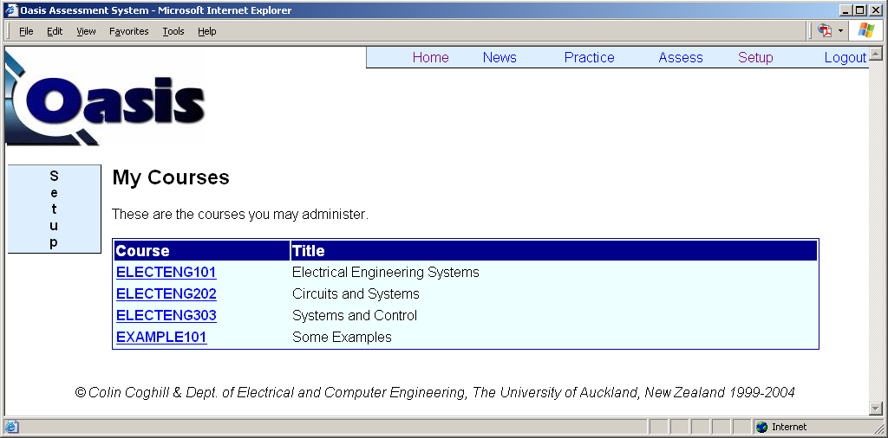

Figure 7.1.1 Newly created EXAMPLE101 course in the Course Administration page

7.2 Course Administration

Figure 7.2.1 shows the Course Administration page that allows us to perform the following operations:

- Create new categories
- Access the question database of each category
- Create and edit new assessments
- View statistics of assessments
- Lookup assessment statistics of a particular student

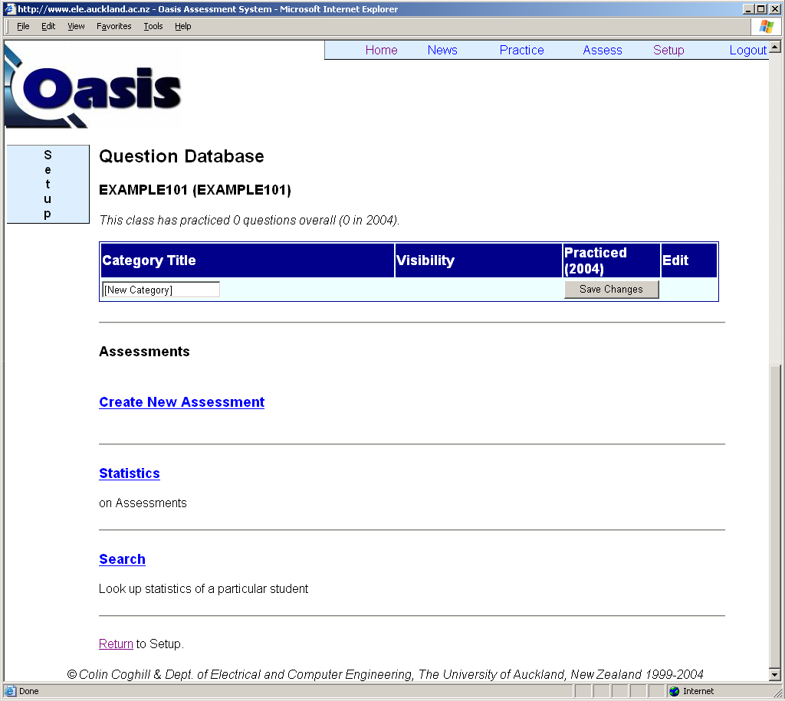

Figure 7.2.1 The Course Administration page

7.3 Creating New Categories

To create a new category, simply enter the required category name into the text box labelled [New Category] and click on the Save Changes button. Figure 7.3.1 shows that we have created two new categories – Easy Questions and Hard Questions.

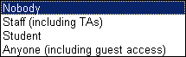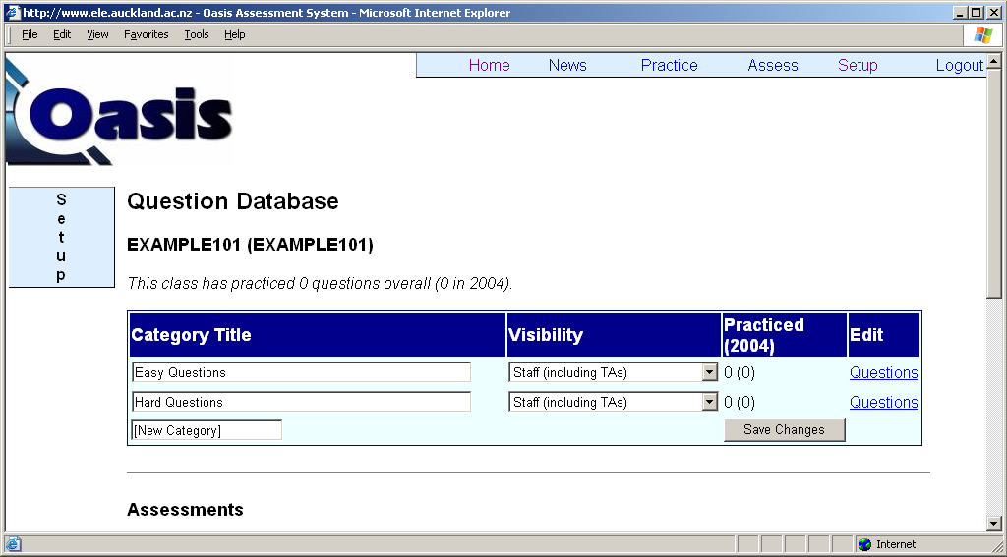
Total number of attempts at the practice questions and the number of attempts in year 2004
Access the question database for entering/editing practice questions

Figure 7.3.1 Two new categories created for EXAMPLE101

The Visibility option defines which users will be able to view and access the categories in the Practice section:

- Nobody: The category will not display for any user in the Practice listings. This is useful if questions in the category are not functional or not being used for the current semester or year.

- Staff: The category will be visible to and accessible by any user with staff account, i.e. any user with any access rights for the course assigned to them. Use this option if the questions in the category are not to be practised by students (for example, the questions may still be under development).

- Student: All student users (enrolled in the course) and all staff users will be able to view and access the category. Excluded from this list are occasional guest accounts and demonstration accounts. Use this option if the questions are ready for student practice, but you would like to limit access to users from the university. For example, staff may wish to hide the questions from visiting users from other universities.

- Anyone: Any users can view and access the category. This is the most commonly used option for categories containing questions that are ready for student practice.

You can change the title and visibility of a category simply by entering the desired changes and clicking on the Save Changes button.

7.4 Question Database

By clicking on the Questions link next to a category, we can access the question database of that category. Figure 7.4.1 shows the empty question database for our newly created Easy Questions category.

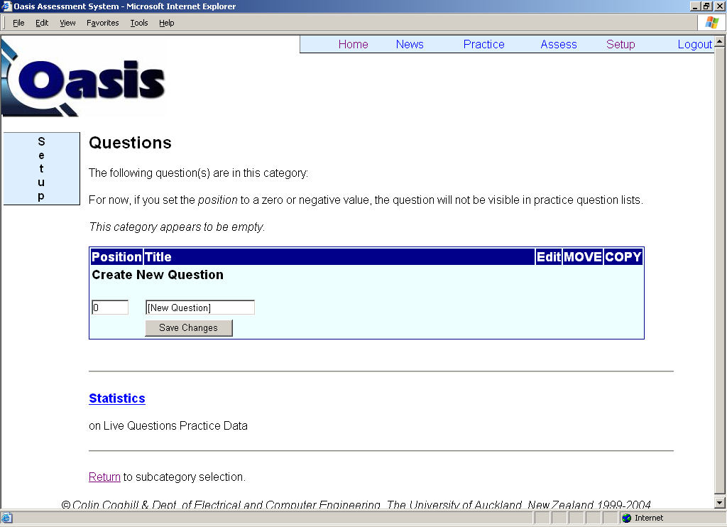

Figure 7.4.1 Empty question database for the category Easy Questions

As shown in Figure 7.4.1, we can also view the statistics on question practice by following the Statistics link.

7.5 Creating New Questions

To create a new question under a category, locate the empty question list and under Create New Question, enter:

- Position of the question on the list – enter 1 to position your question on the top of the list, and so on.

- Title of the question. Enter anything here that describes your question. If a description is not required, you may simply enter “Question One”, “Question two”, etc.

We will create our example question under course EXAMPLE101, category Easy Questions. Figure 7.5.1 shows that we are giving the question a position of 1 since it is the first question in the category. The question is given a title of A Really Easy Question.

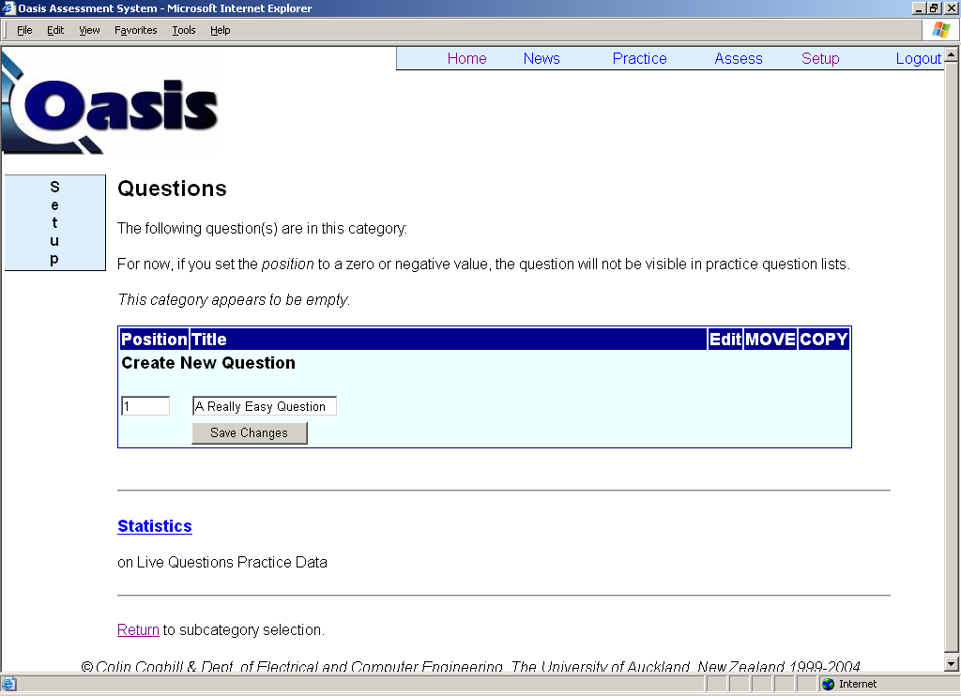

Figure 7.5.1 Creating our example question

Figure 7.5.2 shows the updated question list with the newly created example question.
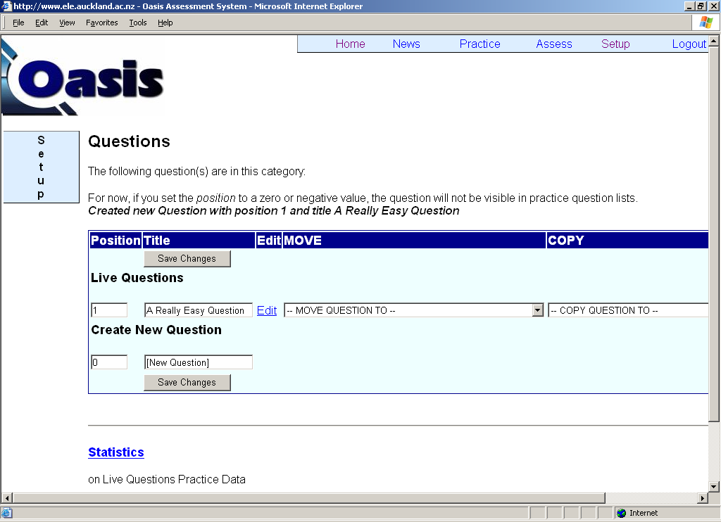

Figure 7.5.2 The updated question list with our newly created example question

You can change the position and title of a question simply by entering the new position and title and click on the Save Changes button.

7.6 Positioning and Hiding Questions

You can easily move a question within a category by changing the Position of the question and click Save Changes. Note that if you give a question (Question A) a Position that is already occupied by another question (Question B), Question A will be positioned immediately after Question B.

If you set the position of a question to 0 or any negative number, the question will be moved to the list of Hidden Questions and will not be shown on the Practice questions list to any user. Figure 7.6.1 shows the example question being hidden. You may want to hide a question from the students because it is obsolete, under development or not yet covered in class and therefore not due for release.

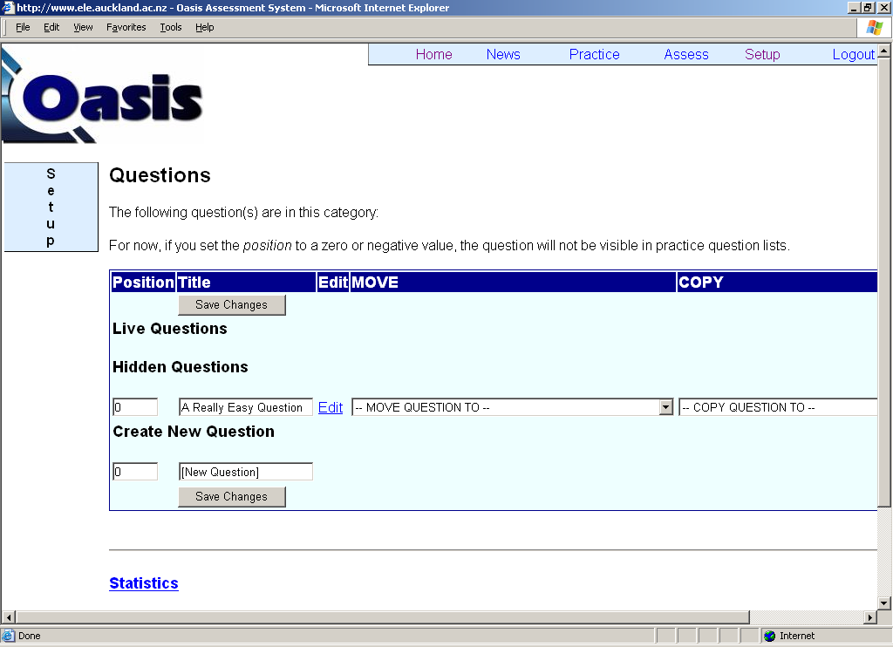

Figure 7.6.1 Hiding our example question in the practice questions

7.7 Copying, Moving and Deleting Questions

Figures 7.5.2 and 7.6.1 show COPY QUESTION TO and MOVE QUESTION TO dropdown lists for each question. These functions allow us to copy or move a question to the same category or another category of the same course, or to another course for which we have staff access.

You may want to copy a question for one of the following reasons:

- Some courses require the same question to appear in more than one category. For example, some computer science courses have slightly different course structures for the BSc students and BE students doing the same course. Therefore, a course may have a category Practice Questions for BSc Students and a category Practice Questions for BE Students, where most questions would be the same.

- A question may be very similar to another question, in which case you can simply encode a question, then copy it and make any required modification to create the other question. This saves you from encoding the second question from scratch.

- You may want to create a backup copy of the question, for example, for testing or debugging purposes.

You may want to move a question for the following reasons:

- The question is created under the wrong category.
- You would like to delete the question (see below).

Figure 7.7.1 shows the content of the MOVE QUESTION TO and COPY QUESTION TO dropdown boxes. We currently have staff access to courses ELECTENG101 and EXAMPLE101, the categories under these courses are therefore listed in the dropdown boxes. We can copy or move our question to any of these categories.

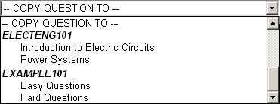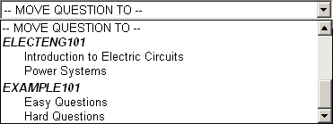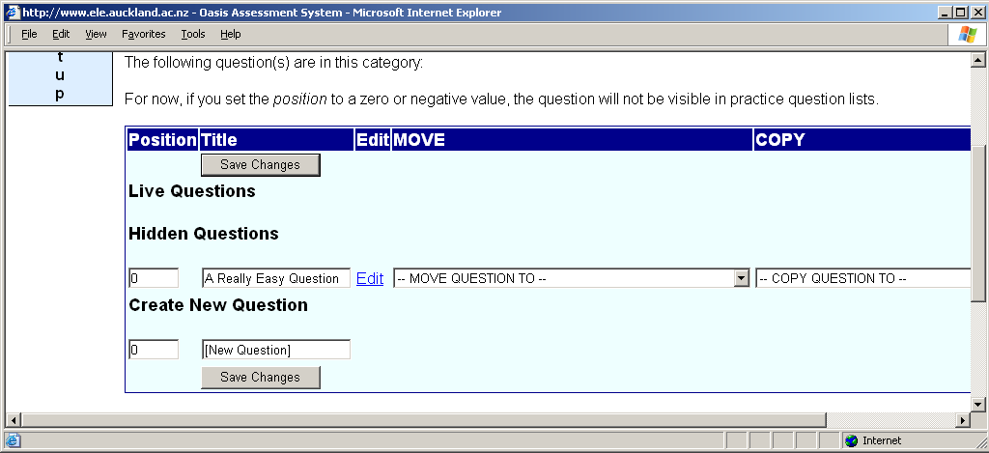

Figure 7.7.1 Categories that we can copy or move our question to

Once created, a question cannot be deleted from OASIS. This protects questions from being deleted accidentally. However, you can still remove unwanted questions from a category. To do this, you can do either of the following:

- Hide the question (see Section 7.6 Positioning and Hiding Questions)

- Create a new category to move all the unwanted questions into. For example, you may name the category Trash, or Deleted Questions.

CHAPTER 8. Entering and Editing Questions on OASIS

This chapter provides a complete guide to question encoding for question encoders.

8.1 The Question Editor

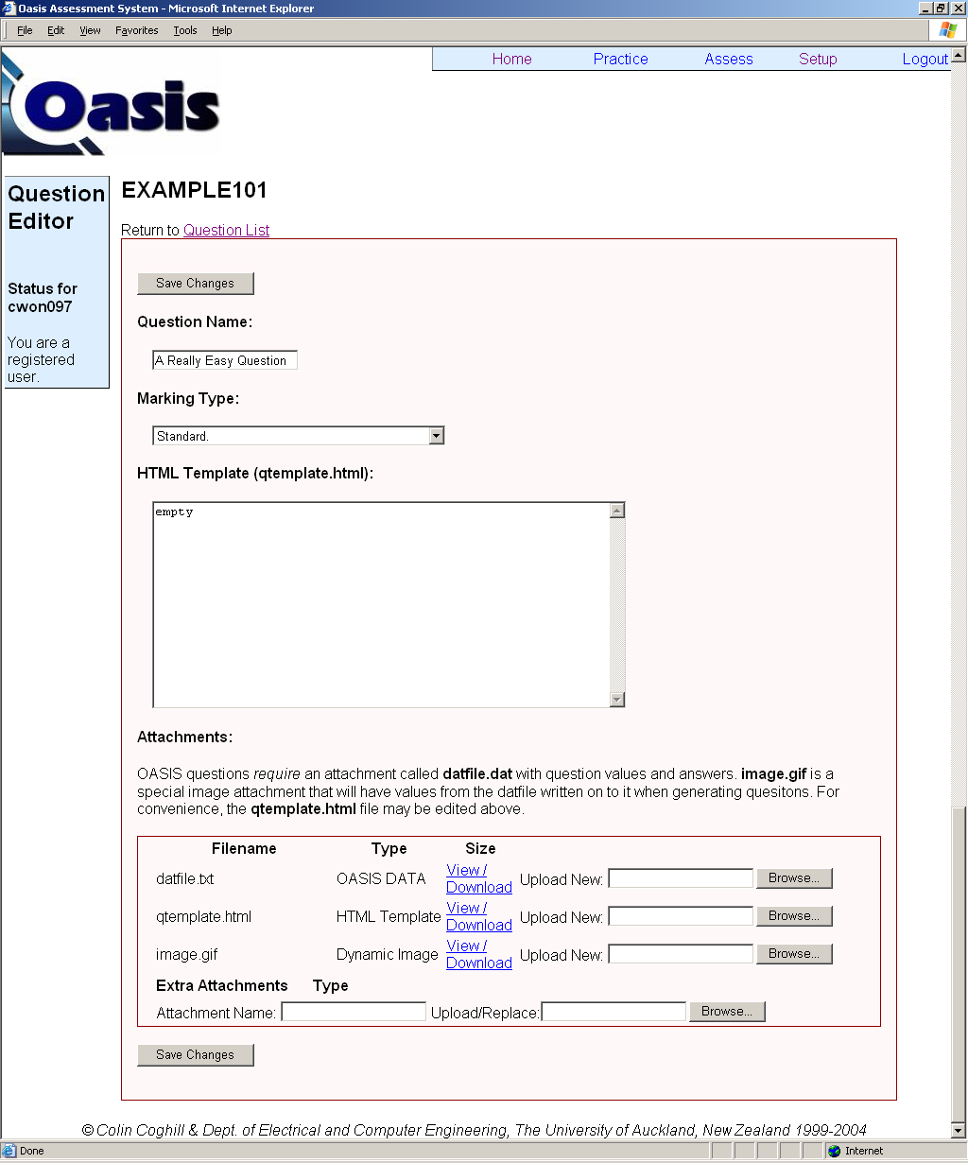

Figure 8.1.1 The Question Editor for “A Really Easy Question”
Each question is entered into its Question Editor, which can be accessed by following the Edit link in the question list for a category (as shown in Figures 7.6.1 and 7.7.1). Figure 8.1.1 shows the question editor for our example question, A Really Easy Question.

All the components that make up a question are to be entered in the Question Editor. As discussed in Section 6.2 How OASIS Generates a Question, a question is made up of three main components:

- HTML template – Questions are written in HTML as webpages.

- Data file – Contains the parameters and answers for all possible variations of the question.

- Attachments – Images and other attachments.

The rest of this chapter will discuss how to generate these components and how to upload them into the Question Editor. We will encode A Really Easy Question as we make our way through the chapter.

8.2 HTML Template

Question encoders must have a basic knowledge of HTML because questions are written in HTML. Basically anything you can put in a webpage can be put in an OASIS question. However, only the most basic HTML tags are used in most cases. Indeed, questions should be laid out as simply and clearly as possible. Question encoders should therefore always seek to encode a question with only the most trivial HTML tags.

- If you are new to HTML, a complete guide to the language is available at: http://www.htmlgoodies.com

- If you are already familiar with HTML, a barebones guide to HTML for quick reference is available at: http://werbach.com/barebones/barebones.txt

8.2.1 Getting Started

The HTML template of the question will be embedded in the question page which contains components such as navigation links, therefore the HTML template should not be enclosed in a <BODY></BODY> tag.

The HTML template can be entered in the Question Encoder in either of two ways:

- Write directly in the textbox labelled HTML Template (qtemplate.html), as shown in Figure 8.2.1.

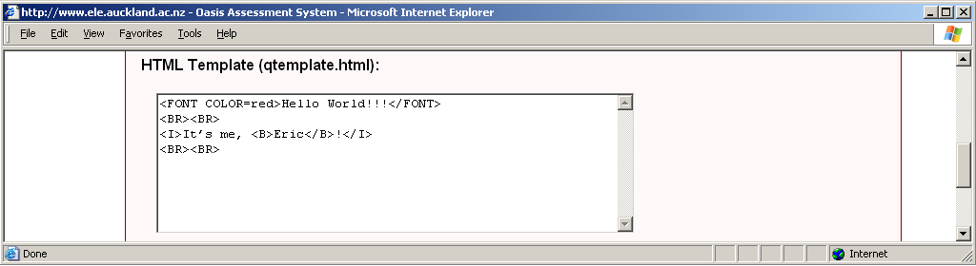

Figure 8.2.1 Entering HTML Template directly in Question Editor

- Write the html template in a separate plain-text file, name it qtemplate.html, and browse to the file for the attachment input labelled qtemplate.html near the bottom of the page, as shown in Figure 8.2.2.

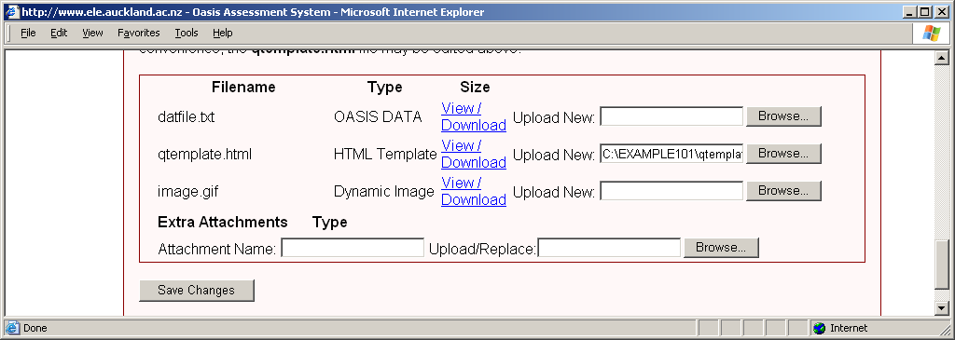

Figure 8.2.2 Uploading HTML template as qtemplate.html in Question Editor

After the above step, click the Save Changes button to upload the HTML template to the question database.

As a simple example, if we upload the following HTML template:

<FONT COLOR=red>Hello World!!!</FONT>
<BR><BR>
<I>It’s me, <B>Eric</B>!</I>
<BR><BR>

Figure 8.2.3 HTML template of our Hello World example

… we get the following displayed for our question:

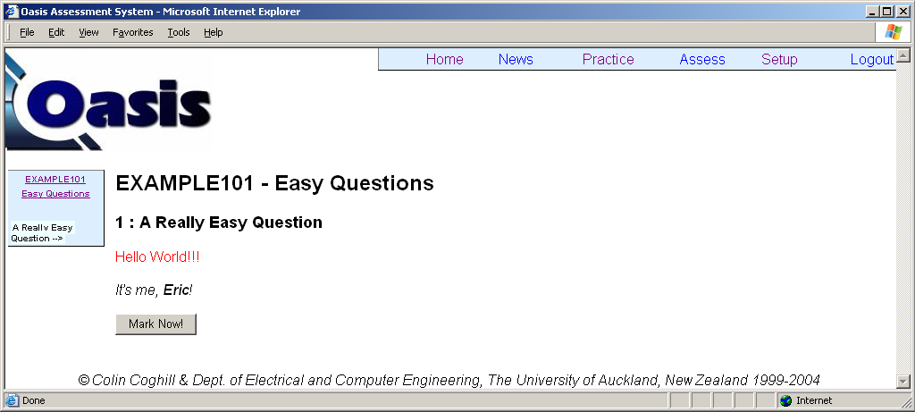

Figure 8.2.4 Generated question for our Hello World example

Notice that a Mark Now! button is automatically appended at the end of the question for submitting the answers. Of course, this button has no use in our Hello World example because we have not asked the student for any answer input and we have not defined any answers.

Special, non-standard HTML tags are provided to use the OASIS specific functions. Like standard HTML tags, these tags are not case-sensitive. The next few sections will discuss the use of these special tags.

8.2.2 Default image

Recall in Section 6.5 Using Images, we mentioned that each question can have a dynamic image that allows text to be added to the image when the question is loaded. Of course, the default image can be a simple static image as well. To use a default image, following the following steps:

- Create your default image in any graphics applications.

- Save your image in GIF format with any filename.

- Browse to your default image file in the attachment input for image.gif in the Question Editor.

- Click on Save Changes to upload your default image.

- Display your image by using the following tag in your HTML template:

<IMG SRC>
It does not matter if you are planning to use a dynamic image for your default image, you still use the same HTML tag to display your image in the question. The dynamic text to be added to your dynamic image is defined in the data file (See Section 8.3 Data File).

For our example question, we have prepared the following default image:

Figure 8.2.5 Default image of our example question

Masses of the two objects will be defined in the data file and added onto the image when the question is loaded.

8.2.3 Extra images

We also mentioned in Section 6.5 Using Images that you can have other images in your question in addition to the default image. These images are not dynamic, that is, you cannot dynamically add text onto them at load time. However, you can prepare different versions of this image and have them displayed on different versions of the question.

No matter how many versions of an image you have prepared, you only call the image once in the HTML template using the following tag:

<IMG SRC var_name>

In the above tag, var_name is an arbitrary name that you give this image. You may have different variables for other parts of your HTML template; therefore this variable name must be unique. For example, if you are to display an image showing different colour maps for different versions of the question, you may want to define the variable name of your image as ColourMap, in which case you will call the image in the HTML template with:

<IMG SRC ColourMap>

To upload your images, browse to your file in the Extra Attachment input in Question Editor. You will have to give a unique Attachment Name to each version of your image (that is, each file that you upload). For example, if the image contains the red colour map, you can name the attachment RedMap, as shown in Figure 8.2.6.

Figure 8.2.6 Uploading images as extra attachments
Click on the Save Changes button to upload the image file to the question database. Note that you have to upload the images one at a time. Therefore, for questions that require different versions of an image, thoughts must be given to design the questions to use as few versions of the image as possible. More efficient designs may use more general images, or incorporate several images into one larger image, to reduce the number of images required. Specificity can be enhanced by the text of the questions.

As discussed above, no further considerations in the HTML template are required to load different versions of an image for different versions of a question. This is achieved through the data file (See Section 8.3 Data File). For example, if you have uploaded three different images, with the attachment names RedMap, GreenMap and BlueMap, then you can call for each image in the data file by assigning the image to the image variable name you defined in the HTML template, that is:

ColourMap = RedMap
ColourMap = GreenMap
ColourMap = BlueMap

This will be discussed in detail in Section 8.3.

Parts four and five of our example question require different images to be loaded for different versions of the question. We will call this image Persons, which is the variable name we will use in our HTML template to display the image. The relevant code is:

<IMG SRC Persons>

We have generated the required images and their attachment names for different versions of the question, shown in Figure 8.2.7:
⓪
Tom
⓪
Bob
①Ann
①Eva
⓪
Tom
⓪
Bob
⓪
Bob
①Ann
①Eva
TBAE
BAE
TB
Figure 8.2.7 Extra images and their names for our example question

8.2.4 Answer Inputs

As discussed in Section 6.3 Types of Questions, there are four types of answer inputs – numerical, text, dropdown list, and multi-choice. This section discusses how to call for each of these inputs.

All answer inputs, regardless of the type of input, require a HTML tag in the form:

<ANSWERn>

In the above tag, n is the position of the answer input in the question. The first answer input has a corresponding HTML tag of <ANSWER1>, while the second answer input requires the tag <ANSWER2>, and so on.

Note that the input fields are in a format predefined by the system which is not configurable. Therefore, you cannot change the size of the textboxes or dropdown lists.

Numerical. To display a text box for numerical answer input, simply use the syntax discussed above.

<ANSWERn>

Text. Again, to display a text box for text type answer input, use the following syntax:

<ANSWERn>

Dropdown list. To display a dropdown list for selectable choices, a slightly more complicated HTML tag is needed:

<ANSWERn SELECT var1, var2, …>

The variables var1, var2, var3… are the variable names given to the choices in the dropdown list. You can give these choices any names as long as they are unique to each other and unique to the rest of the variables in the question. Note that these are just the names given to the choices, not the actual content of the choices. For example, if your fifth question is asking the student to select a fruit from four possible choices, you may name the choices Fruit1, Fruit2, Fruit3 and Fruit4. You would therefore use the following code:

<ANSWER5 SELECT Fruit1, Fruit2, Fruit3, Fruit4>

You can then assign choices to these variables in the data file, which will be discussed in detail in Section 8.3 Data File. For example, in the data file, you can assign the choices to be displayed in the question as:

Fruit1 = apple, Fruit2 = orange, Fruit3 = pear, Fruit4 = banana

Multi-choice. To use a multi-choice question in your question, use the following HTML tag:

<ANSWERn MULTI var1, var2, …>

As for dropdown list questions, var1, var2, … are the unique variable names you give to the choices in the question. The actual choices will be defined in the data file.

8.2.5 Data Variables

As discussed in Section 6.6 Changing Text in a Question, you may change the text between different versions of a question. To achieve this, simply use the following tag in the HTML template at the place where you need to place the changing text:

<VAL name>

In the above HTML tag, name is the variable name given to the changing text. The name is arbitrary but must be unique among the variables defined in the HTML template. You do not need to include the actual text in the HTML template, as the text is supposed to be changing across different versions of the question. The actual text is defined in the data file and assigned to the variable at load time.

The last part of our example question requires that a different colour is asked for different versions of the question. We therefore include the following code in the HTML template, where the actual colour to be asked appears:

<VAL Colour>

We can then define in the data file different colours for the Colour variable for different versions of the question.

8.2.6 HTML Template for Our Example Question

We have now covered everything we need to know to write the HTML template of our example question, shown in Figure 8.2.8.

<IMG SRC>
<BR>Total mass = <ANSWER1>
<ANSWER2 SELECT A,B,C>
<BR>One-third of total mass = <ANSWER3> kg
<BR><BR><IMG SRC Persons>
<BR><BR>How many persons are shown in the picture above?
<BR><ANSWER4 MULTI Q,R,S,T>
The name of the person in
<B><VAL Colour></B> is
<ANSWER5><BR>

Figure 8.2.8 HTML template for our example question

8.3 Data File

As discussed in Section 6.2 How OASIS Generates a Question, all the parameters and answers of each possible variation of a question are defined in the data file of the question. The data file is a plain-text file with the filename datfile.txt.

8.3.1 Contents of the Data File

A data file usually contains many rows, each row defining the parameters and answers for a variation of the question. When a question is loaded, a row is selected randomly from its data file. The parameters and answers specified in this row are then used to generate the version of the question displayed to the student. It is common for a science or engineering question to have 300 to 500 defined versions.

Each row of the data file must be written in the following format:

X1,Y1,V1;X2,Y2,V2;...|A1:T1,A2:T2,...|NAME1=VALUE1,…,NAMEn=VALUEn

The above symbols are described below:

Xn,Yn,Vn The X and Y coordinates (Xn,Yn) of the text (Vn) to be dynamically added onto the default image at load time. Xn and Yn originate from the top left corner of the default image. Vn can be any text, including symbols available on standard US-layout keyboards and may contain spaces. The dimension of the text is fixed by the system and depends on the characters in the text. The location and dimension of the text may not be the same as you expect or calculate. It is therefore very important to fine tune Xn and Yn, or even the default image, to achieve the effect that you want.

Some Unicode characters are also supported, for example, the following Vn - &alpha; - can be used to display the α symbol. A list of the codes (entities) for common symbols can be found in:
http://evolt.org/article/A_Simple_Character_Entity_Chart/17/21234/index.html

However, some characters may not be supported by OASIS. You must therefore check that your symbol is properly displayed in the image. If your symbol is not supported, then you will have to use another supported symbol, or use plain text, for example, alpha; or, if the symbol does not change across different versions of the question, you should incorporate the symbol in the original default image.

As an example, we created Figure 8.3.1 which is 130 pixels by 50 pixels.



Figure 8.3.1 A blank image (with black border)
We will add text to the image using the following row in our data file:

10,5,V1 goes here;20,25,V2 here

The resulting image displayed in the question is shown in Figure 8.3.2 and enlarged in Figure 8.3.3. You can observe that the added text does not start exactly at the defined locations.

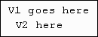

Figure 8.3.2 Generated default image

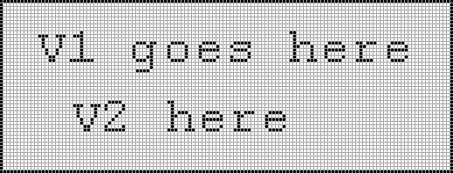

Figure 8.3.3 Generated default image (Enlarged)

For our example question, after some fine-tuning, we can place the values of the masses nicely on the objects in the default image (Figure 8.3.4), using the following definition in the data file:

15,24,120kg;124,27,40kg

Figure 8.3.4 Generated default image for our example question

Note that the values of the masses vary across different versions of the question, but the positions of X1,Y1 (15,24) and X2,Y2 (124,27) remain the same.

If you have a default image but you do not require any text to be dynamically added, simply use an empty Xn,Yn,Vn section.
NAMEn=VALUEn
Before we discuss the An:Tn section, we will discuss the NAMEn=VALUEn section as it directly affects the content of the former section. This section assigns values (VALUEn) to the variables defined in the HTML template (NAMEn). Recall that these variables include:

- Variables for changing the image
- Variables for changing text
- Variables for choices in a dropdown list question
- Variables for choices in a multi-choice question

These variables, in addition to the dynamic text in the default image, make up all the parameters that define the question displayed to the students. To assign the value of a variable, simply use the following syntax:

NAME=VALUE

The variable names, NAMEn, must match the variable names define in the HTML template. VALUEn assigned can be any text and may include spaces. Some Unicode characters are also supported, for example, the following Vn - &alpha; - can be used to display the α symbol. A list of the codes (entities) for common symbols can be found in:

http://evolt.org/article/A_Simple_Character_Entity_Chart/17/21234/index.html

However, some characters may not be supported by OASIS. You must therefore check that your symbol is properly displayed in the question. If your symbol is not supported, then you will have to use another supported symbol, or use plain text, for example, alpha, or as a last resort, prepare your symbol as an image file and display the image by using the <IMG SRC NAME> tag in the HTML template.

We have used the following variables in the HTML template of our example question:

- A, B, C for the multi-choice question
- Q, R, S, T for the dropdown list question
- Persons for the changing image
- Colour for the changing text

The NAMEn=VALUEn section for three versions of our question may be:

|A=kg,B=g,C=N,Q=1,R=2,S=3,T=4,Persons=TBAE,Colour=Blue
|A=g,B=kg,C=N,Q=6,R=4,S=2,T=8,Persons=TB,Colour=Green
|A=g,B=N,C=kg,Q=1,R=3,S=5,T=7,Persons=BAE,Colour=Red
Notice that the NAMEn=VALUEn pairs are separated by commas. The section starts with a vertical bar that divides itself from the previous section. If you are not using any variable in your question, then you would not have the NAMEn=VALUEn section and the preceding vertical bar.

An:Tn This section defines the value for each answer (An) and its tolerance (Tn). A1 is the answer for ANSWER1, A2 is the answer for ANSWER2, and so on. These answers should match the parameters (for example, the resistance values used) of the same version of the question defined in the NAMEn=VALUEn section.

For numerical answers, simply state the answer to any decimal points or significant figures you want, and the associated tolerance (in percentage), for example, 350.3867:2 and 150:0. As discussed before, if you define the answer without the tolerance value, for example, 350.3867 and 150, a default tolerance of 1% is automatically adopted by OASIS.

For text answers, such as Good or Tommy, the tolerance value has no effect and therefore should not be stated.

For dropdown list and multi-choice questions, the answers are defined as the position of the choice, in the order you defined in the HTML template. For example, if you have the following dropdown list defined in the HTML template:

<ANSWER3 SELECT FRUITa, FRUITb, FRUITc>

and in the NAMEn=VALUEn section of your data file, you have defined the values for the three variables as:

FRUITa=apple,FRUITb=pear,FRUITc=orange

the value you should define as A3 in your data file is therefore 1 if the correct answer is apple, 2 if the correct answer is pear, and 3 if the correct answer is orange.

We have five parts in our example question and the An:Tn section for three versions of our question may be:

|130:0,1,43.33:1,4,Tom
|145:0,2,48.33:1,3,Bob
|160:0,3,53.33:1,2,Ann

The different sets of An,Tn are separated by a comma. The section starts with a vertical bar, which must be in place even if you have an empty Xn,Yn,Vn section.

8.3.2 Putting It Together

We have already discussed in the previous section that each row of the data file is written in the following format:

X1,Y1,V1;X2,Y2,V2;...|A1:T1,A2:T2,...|NAME1=VALUE1,…,NAMEn=VALUEn

However, we have deliberately omitted a little feature of the data file so far – the first row of the data file must state the number of versions of the question defined in the file. For example, if you have defined 300 versions of the question, then the first row of the data file simply reads 300, and the actual definitions (300 rows) actually start from row 2.

We have prepared three versions of our example question for simplicity’s sake. The final data file is shown below:

3
15,24,100kg;124,27,30kg|130:0,1,43.33:1,4,Tom|A=kg,B=g,C=N,Q=1,R=2,S=3,T=4,Persons=TBAE,Colour=Blue
15,24,110kg;124,27,35kg|145:0,2,48.33:1,3,Bob|A=g,B=kg,C=N,Q=6,R=4,S=2,T=8,Persons=TB,Colour=Green
15,24,120kg;124,27,40kg|160:0,3,53.33:1,2,Ann|A=g,B=N,C=kg,Q=1,R=3,S=5,T=7,Persons=BAE,Colour=Red

Figure 8.3.5 Data file of our example question

8.3.3 Generating Solutions

For the example question, we simply typed up each row of the data file. Of course this is not possible if you would like 500 versions of your question. In that case, you need to write a little program using the language of your choice (usually MATLAB or C) to generate the data file. If you have no background in programming, you may also generate the data file using Microsoft Excel. In any case, make sure you state the number of versions in the first row of the data file.

8.3.4 Uploading the Data File

To upload your data file onto the question database, simply browse to your datfile.txt for the attachment labelled datfile.txt (see Figure 8.3.6) and click the Save Changes button.

Figure 8.3.6 Uploading the data file

8.4 Smart Marking

As discussed in Section 6.3 How OASIS Marks a Question, there are two types of marking:

- Standard marking which uses a strict comparison between the user’s answers and the answers defined in the data file.

- Smart marking which allows more advanced processing of the user’s answers, for example, consequential marking for consistent errors. It also allows allocating marks other than the default mark of 1 for correct answers, and to display comments other than the default comments of Correct and Incorrect.

You can choose which type of marking you require in the dropdown list labelled Marking Type in the Question Editor (Figure 8.1.1), by choosing either Standard or Smart.

If your question requires only standard marking, you do not need to do anything besides uploading the HTML template, images and data file. However, if your question requires Smart Marking, then more work is required, as explained in the rest of this section.

8.4.1 How Smart Marking Works

In smart marking, you are replacing the standard marking provided by OASIS with new marking instructions, in the form of a script written in the programming language Python. Therefore, to encode questions which require smart marking, you need to be able to write simple scripts in Python. To learn more about Python, you can visit the official website at http://www.python.org.

8.4.2 Using Smart Marking

In order to use Smart Marking for your question, you need to do two things in the Question Editor:

- Select Smart in the Marking Type dropdown list.

- Develop your Python script (which will be discussed shortly), save it as marker.py and upload it onto the question database as an Extra Attachment with the attachment name marker.py, as shown in Figure 8.4.1.

Figure 8.4.1 Uploading the Python script marker.py

8.4.3 System Variables

The following variables are available for use in your Python script:

Gn | User’s answer for ANSWERn
An | Answer for ANSWERn, defined in the data file, discussed in Section 8.3
Tn | Tolerance for ANSWERn, defined in the data file, discussed in Section 8.3
Mn | Mark allocated for ANSWERn
Cn | Comment defined for ANSWERn
NAME | Variable name defined in the HTML template
Xn,Yn,Vn | X- and Y-coordinates for the dynamic text Vn on the default image, discussed in Section 8.3

Table 8.4.1 System variables for smart marking

Basically, for each part of the question, you are performing certain processing on the user’s answer Gn, then comparing the result with the correct answer An. According to the result of the marking, you have to allocate the mark (Mn) and comment (Cn). The variables Xn, Yn, Vn and NAME are rarely used.

Because in using smart marking, the standard marking provided by OASIS is totally disabled, you must provide marking for each answer. If you do not assign a mark and comment for an answer, then a default mark of 0 and a comment of Incorrect are given, even if the user entered an answer that matches the answer stored in the data file.

The following is an example script showing the simplest form of marking of ANSWER3:

if G3==A3:
M3 = 5
C3 = "Correct. Excellent!"
else:
C3 = "Sorry, incorrect.”

The script compares the user’s input for ANSWER3 with the answer stored in the data file. If the two match exactly, then the user is given 5 marks and a comment of “Correct. Excellent!” If the answers do not match, then the user receives 0 marks and a comment of “Sorry, incorrect.” Note that we have not specified in the code the mark the user receives if the answers do not match, because by not specifying M3, the default mark of 0 will be given.

8.4.4 Python Functions Available in OASIS

You can use the functions provided in the standard Python libraries and the math function library. However, for security reasons, OASIS does not support any I/O functions such as file writing.

In most cases, we cannot use marking based only a simple, strict comparison of the user’s answer with the data file answer (e.g. if G3==A3), because we may want to provide a certain tolerance to the numerical answers. This requires the use of the defined tolerance Tn. OASIS provides the following function for this purpose:

withinTolerance(Gn,An,Tn)

The function checks whether Gn is within the tolerance Tn of An and returns a Boolean result. Basically, you would want to use this function to check all your numerical answers. For example, we should rewrite the simple code in the previous section as:

if withinTolerance(G3,A3,T3):
M3 = 5
C3 = "Correct. Excellent!"
else:
C3 = "Sorry, incorrect.”

8.4.5 The End-of-Line Character

Special care must be taken for the end-of-line characters in your code. OASIS requires that each line is terminated by a new line character (\n). However, most Windows based programs also append a carriage return character (\r) after the new line character. This results in OASIS returning an error message and failing to proceed with the marking. You must therefore pay attention to how you terminate your lines. For example, the application Notepad provided in Windows is not suitable for developing your marker.py because it terminates each line with the characters \n\r. WinPython is an example of a program that does not have this problem.

8.4.6 The Python Code for Our Example Question

if G1==A1:
M1 = 1
C1 = "Correct"
if G2==A2:
M2 = 0.5
C2 = "Correct Unit"
try:
G3n = G1/3;
except:
G3n = A3;
if withinTolerance(G3,A3,T3):
M3 = 1
C3 = "Correct"
elif withinTolerance(G3,G3n,T3):
M3 = 1
C3 = "Consistent with Part 1"
if G4==A4:
M4 = 1
C4 = "Correct"
if G5==A5:
M5 = 0.5
C5 = "Correct"

Figure 8.4.6 marker.py for our example question

8.5 Putting Everything Together

We have now developed all the content for our example question:

Default image
⓪
Tom
⓪
Bob
①Ann
①Eva
⓪
Tom
⓪
Bob
⓪
Bob
①Ann
①Eva
TBAE
BAE
TB
Figure 8.5.1 Images used in our example question

if G1==A1:
M1 = 1
C1 = "Correct"
if G2==A2:
M2 = 0.5
C2 = "Correct Unit"
try:
G3n = G1/3;
except:
G3n = A3;
if withinTolerance(G3,A3,T3):
M3 = 1
C3 = "Correct"
elif withinTolerance(G3,G3n,T3):
M3 = 1
C3 = "Consistent with Part 1"
if G4==A4:
M4 = 1
C4 = "Correct"
if G5==A5:
M5 = 0.5
C5 = "Correct"
<IMG SRC>
<BR>Total mass = <ANSWER1>
<ANSWER2 SELECT A,B,C>
<BR>One-third of total mass = <ANSWER3> kg
<BR><BR><IMG SRC Persons>
<BR><BR>How many persons are shown in the picture above?
<BR><ANSWER4 MULTI Q,R,S,T>
The name of the person in
<B><VAL Colour></B> is
<ANSWER5><BR>

Figure 8.5.2 HTML template for our example question

Figure 8.5.3 Data file of our example question

3
15,24,100kg;124,27,30kg|130:0,1,43.33:1,4,Tom|A=kg,B=g,C=N,Q=1,R=2,S=3,T=4,Persons=TBAE,Colour=Blue
15,24,110kg;124,27,35kg|145:0,2,48.33:1,3,Bob|A=g,B=kg,C=N,Q=6,R=4,S=2,T=8,Persons=TB,Colour=Green
15,24,120kg;124,27,40kg|160:0,3,53.33:1,2,Ann|A=g,B=N,C=kg,Q=1,R=3,S=5,T=7,Persons=BAE,Colour=Red

Figure 8.5.4 marker.py for our example question
We can now upload all the above content to the question database in the Question Editor. The question will be available for practice under course EXAMPLE101, category Easy Questions and question title A Really Easy Question. We should then carefully and thoroughly check that the question is functioning properly. After verifying that the question is bug free, we can activate the question for student practice by changing the Visibility setting of the category Easy Questions to Anyone (See Section 7.3 Creating New Categories).

8.6 Notes

8.6.1 Updating Questions

When you make changes to a question, you may find that it is not updated in the practice question, even if you reload the webpage, or if you log off OASIS and log in again. In order to see the changes you made, you must first click on the Mark Now! button on the question page to complete one attempt of the old version of the question. The question will be updated to the new version the next time you load the question. This is a deliberate design in OASIS to make sure any changes you make to the question will not affect any student currently working on the question. These students will only see the new version in a new attempt at the question.

The above situation only applies to students that have already attempted, or loaded, the old version of the question. Students loading the question for the first time will be able to see the new version. However, you may want any changes you made to be immediately available to any student making a new attempt at the question. To do this, you will have to “delete” the old question (by moving it to another category) and upload the new question as a new question but with the same question name as the deleted question. This does not affect any students currently attempting the old version of the question. Any user who loads the question will now see the new version.

8.6.2 System Errors

If OASIS returns an error when loading the question, check the variables in the HTML template and the variables in the data file.

If OASIS returns an error while marking, check the answers in the data file and check the Python marking script if smart marking is used.

CHAPTER 9. Administration of Course Assessments

Online course assessment in OASIS was introduced in Section 3.2 Sitting an Assessment. This chapter provides a complete guide to creating and administering these assessments.

9.1 Creating an Assessment

To create a new assessment for a course, enter the Course Administration page of the course and follow the Create New Assessment link, shown in Figure 9.1.1.



Figure 9.1.1 Creating new assessment

You will be directed to the Assessment Creation page, shown in Figure 9.1.2 where you will enter the properties and questions for the assessment. We discuss the various inputs in the Assessment Creation page below.

Assessment Title Enter any title for the assessment, for example, Test 1, or Sample Assessment.

Exam or Assignment Choose either Exam or Assignment. This is only provided as information to the students. It does not affect the way OASIS behaves.

Make Available Choose the date and time that the assessment will move from the list of Upcoming Assessments to the list of Available Assessments. You may enter a date that has already been passed, in which case the assessment will be listed as an Available Assessments immediately upon creation.

Close Time Choose the date and time that the assessment will close. At this time, the assessment will move to the list of Past Assessments and no more attempts at the assessment are allowed.

Duration Enter the time (in minutes) students have to finish their assessment.

Extra Instructions A note displayed to the students at the start page of the assessment. You may provide special notes and instructions to students here. See Figure 3.2.3.
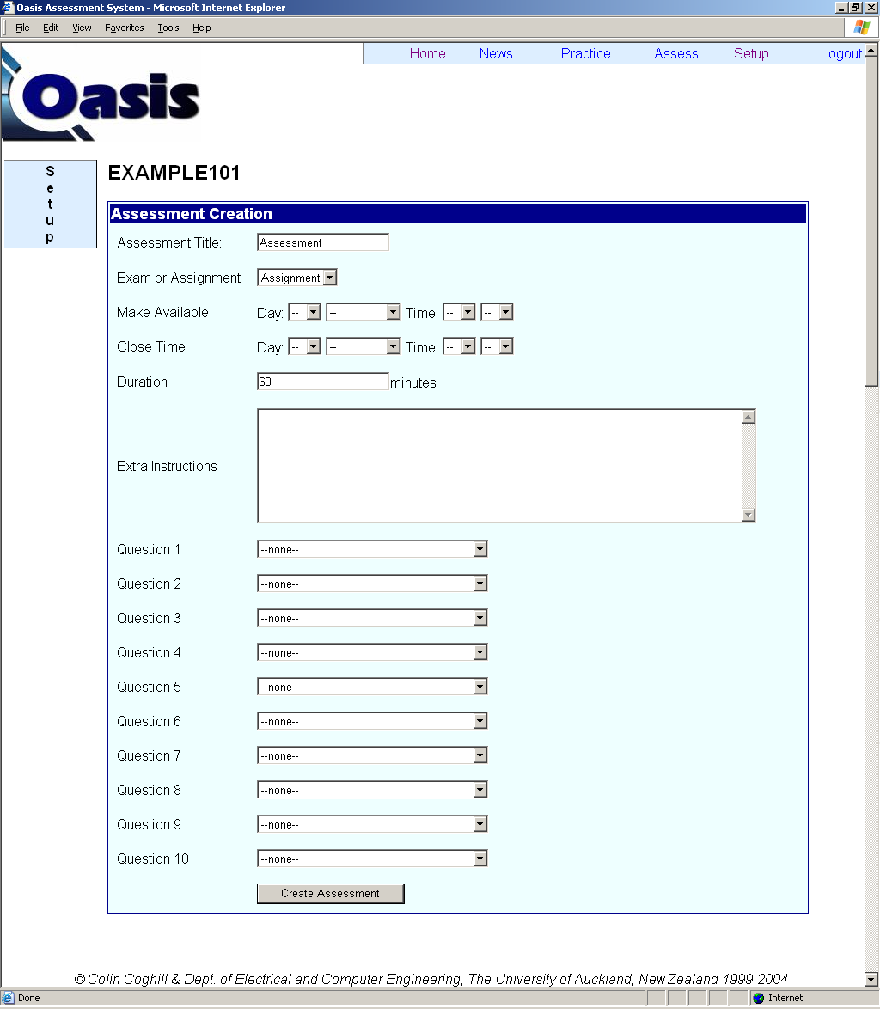

Figure 9.1.2 The Assessment Creation page

Questions OASIS allows you to enter up to 10 questions in an assessment. Only practice questions from the course may be used in an assessment. All the questions from all categories of the course are listed in the dropdown list for each question. The idea behind OASIS is that students always get a chance to practise for questions that may come up in an assessment, by doing practice exercises. However, if you wish to include questions in the assessment that students have not practised on, simply create those questions as practice questions and hide them from the students (either by setting the Visibility of the category to Staff, or hide the questions by giving them a position of 0). These questions are hidden from the students for practice, but will show up in the question dropdown lists in the Assessment Creation page for you to include in the assessment.

9.2 Modifying an Assessment

After an assessment is created, you may preview the assessment (given that you have the access right to Preview Assessments) by choosing it from the Assess page, even though the assessment is not due for student participation. Created assessments are also listed in the Course Administration page, as shown in Figure 9.2.1. Note that the date shown before the title of the assessment is the make available date of the assessment.

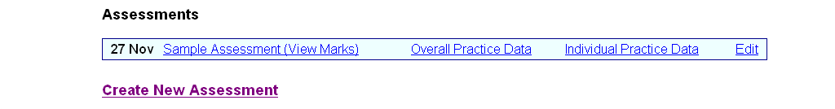

Figure 9.2.1 Available assessments in the Course Administration page

You may modify any of the properties of any created assessments of the course, by following the Edit link of the assessment in the Course Administration page, which will direct you to the Assessment Creation page again.

Any changes you made will be reflected in the list of assessments. However, note that once an assessment is closed, you cannot re-activate it by changing its Close Time. If you simply want to review the assessment, you may do so by choosing the assessment from the list of Past Assessments, given that you have the access right to Preview Assessments.

9.3 Retrieving Assessment Results

Once an assessment is closed, you may view the results of the assessments by following the links shown in Figure 9.2.1.

9.3.1 View Marks

By following the View Marks link, you will obtain the result of each student in the course; the mark they received for each question in the assessment and the total mark, as shown in Figure 9.3.1. The course and the details of the students are censored in this example for privacy reasons.

The Status of the result for each student can be either Marked, which specifies marking by OASIS, or Live, which specifies manual alteration of the mark, sometimes required because of a badly designed question or a student who used the Back button of the browser during an assessment, resulting in his or her answers not being saved.

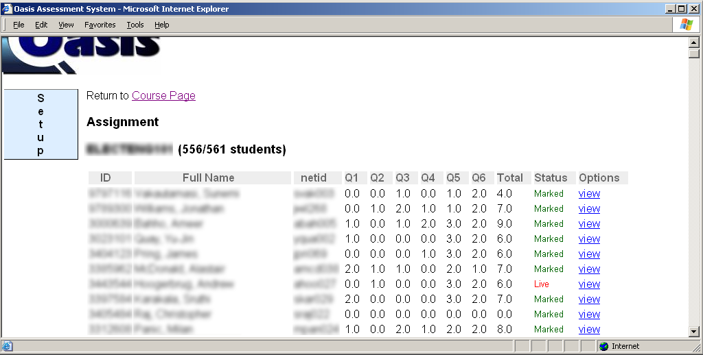

Figure 9.3.1 Viewing assessment marks

By following the view link, you will be able to see the exact answer that the student submitted for each question.

At the bottom of the page, you can also find a list of the students that are enrolled in the course but had not taken the assessment, as shown in Figure 9.3.2.



Figure 9.3.2 List of assessments not started

9.3.2 Overall Practice Data

By following the Overall Practice Data link, you will obtain statistics on the practice on the assessment questions (recall that assessment questions are available as practice questions most of the time). Figure 9.3.3 shows that, for each question, you can find out the number of students that have attempted the question, the total number of attempts made, the class average, the standard deviation, the maximum result and the minimum result obtained.
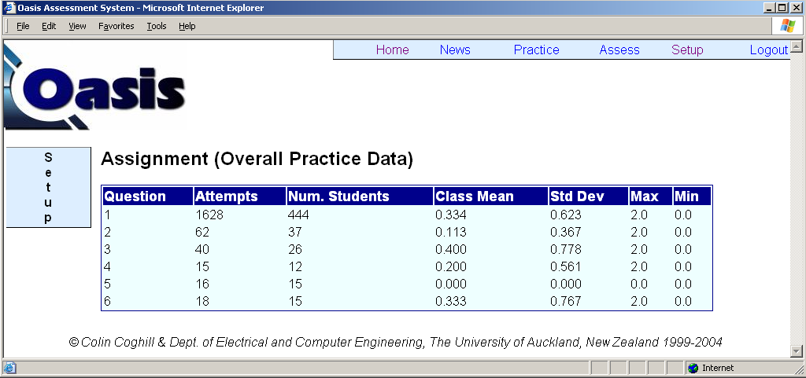

Figure 9.3.3 Statistics on overall practice data

9.3.3 Individual Practice Data

By following the Individual Practice Data link, you can find out how each student did on each question, as shown in Figure 9.3.4. For each student, the number of attempts he or she made on each question is presented, along with the maximum, minimum and average mark he or she got for that question.

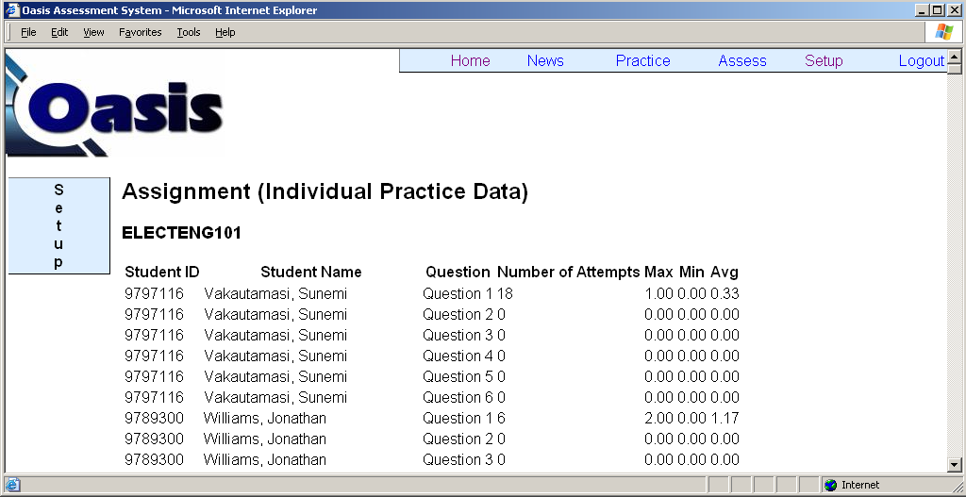

Figure 9.3.4 Statistics on individual practice data

9.4 Deleting Assessments

For security reasons, OASIS does not provide any function for deleting an assessment. If you need to delete an assessment, you need to send your request to oasis@ece.auckland.ac.nz.

CECIL is available at: http://www.cecil.edu

